**Post Op Complications of Calf #196 at UWI Field Station**

**1 day Post op**

RR= 88

T=40.5 degrees Celsius

HR=108

Wound site on scrotum was swollen and tissue was seen protruding out. The animal showed no signs of pain when scrotum was palpated. Supervising surgeon was consulted and advised the group to monitor the animal and to contact him if signs of infection were observed.

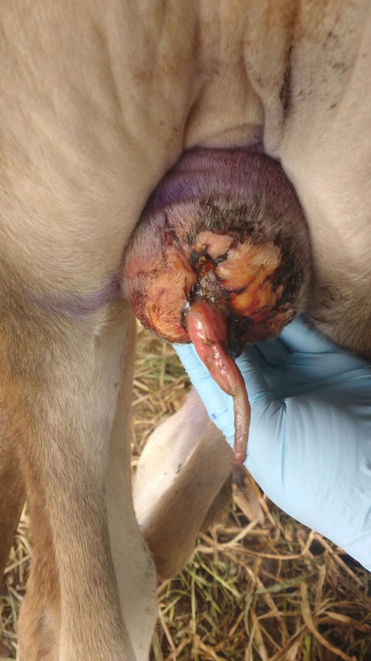

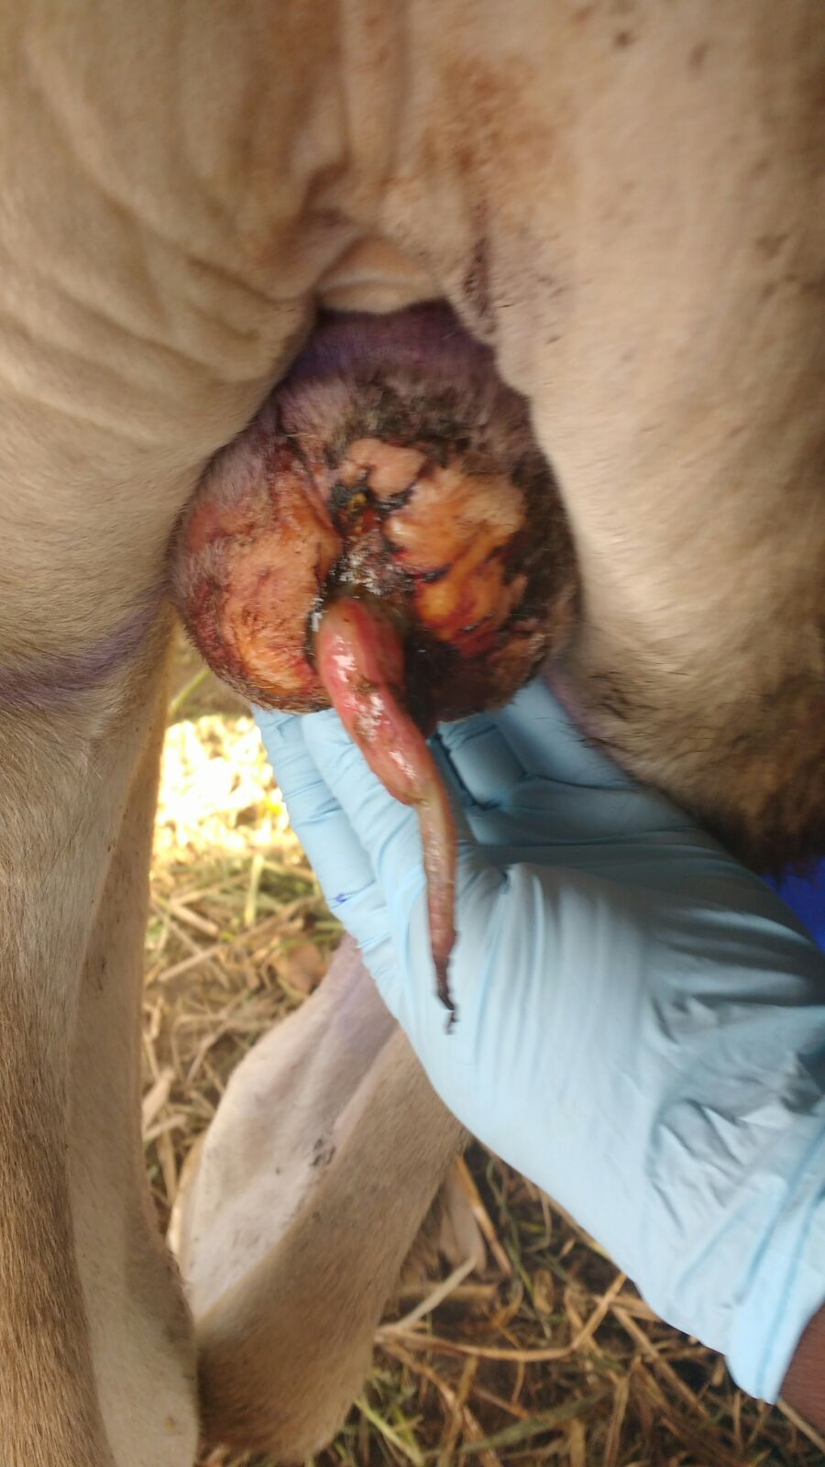

3 days post op

RR=88

T=40.5

HR=112

Protruding tissue had reduced in length and showing signs of drying up nicely. There was no sign of infection. Swelling was reduced. Animal was BAR, and showed no reluctance to move.

