Gastrointestinal tract, right side, horse
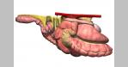
In its strictest definition, the term “colic” means abdominal pain. Throughout the years, it has become a broad term for a variety of conditions that cause a horse to exhibit clinical signs of abdominal pain. Consequently, it is used to refer to conditions of widely varying etiologies and severity. To understand these etiologies, make a diagnosis, and initiate appropriate treatments, veterinarians must first appreciate the clinically relevant aspects of equine GI anatomy, the physiologic processes involved in movement of ingesta and fluid along the GI tract, and the extreme sensitivity of the horse to the deleterious effects of the structural components of the bacteria that reside within the lumen of the intestine.
GI ANATOMY
Gastrointestinal tract, left side, horse
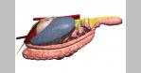

Gastrointestinal tract, organs removed, left side, horse
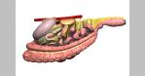
The horse is a monogastric animal, with a relatively small stomach (capacity 8–10 L) that is located on the left side of the abdomen beneath the rib cage. The junction of the distal esophagus and the cardia is a functional 1-way valve, permitting gas and fluid to move into the stomach but not out. Consequently, conditions that impede the normal aboral movement of gas and fluid through the small intestine may result in severe dilation and rupture of the stomach. Because of its position, the stomach is difficult to visualize with radiography or ultrasonography in large adult horses. The smaller size of the foal, however, permits assessment of gastric emptying by contrast radiography.

Ileum and cecum, horse
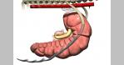
The small intestine comprises the duodenum, jejunum, and ileum, with the latter joining the cecum at a distinct ileocecal junction. The duodenum is positioned primarily dorsally on the horse's right side, where it is suspended from the dorsal body wall by a short mesentery of 3–5 cm. Consequently, the duodenum is not involved in small-intestinal displacements involving the mesentery (volvulus). At the base of the cecum in the right paralumbar fossa region, the duodenum turns toward the midline. It is at this point that the duodenum, if distended with gas or fluid (eg, in horses with proximal enteritis), can be felt on rectal examination.
As the small intestine reaches the dorsal midline, it turns anteriorly, its mesentery lengthens, and it becomes known as the jejunum. The characteristic long mesentery allows loops of the jejunum to rest on the contents of the ventral portion of the abdomen. The jejunum is ~65 ft (19.5 m) long; its length, coupled with its long mesentery, allow it to be involved in small-intestinal volvulus and incarcerations. At the end of the jejunum, the wall of the intestine becomes more muscular, the lumen is narrowed, and an additional mesenteric attachment becomes apparent. The last 18 in. (45 cm) of the small intestine, the ileum, joins the cecum at its dorsal medial aspect. This junction is identified by the attachment of the ileocecal fold from the ileum to the dorsal band of the cecum. This ileocecal fold is used as a landmark to locate the ileum during abdominal surgery.
From the ileum, the ingesta enters the cecum, a large, blind-ended fermentation vat situated primarily on the horse's right side, extending from the region of the paralumbar fossa to the xiphoid cartilage on ventral midline. The cecum is 4–5 ft (1.2–1.5 m) long and can hold 27–30 L of feed and fluid. Under the influence of the cecal musculature, the ingesta in the cecum is massaged, mixed with microorganisms capable of digesting cellulose, and eventually passed through the cecocolic opening into the right ventral colon. The attachment of the cecum to the dorsal body wall is wide, thus minimizing the likelihood the cecum can become displaced or twisted on its own.
The right ventral colon is divided into sacculations that help mix and retain plant fibers until they are digested. It is positioned on the ventral aspect of the abdomen, extending from the flank region to the rib cage. The ventral colon then turns toward the left, becoming the sternal flexure and then the left ventral colon. The left ventral colon, which also is large and sacculated, passes caudally to the left flank area. Near the pelvic region, the diameter of the colon decreases markedly, and the colon folds back on itself. This region, called the pelvic flexure, is the initial portion of the unsacculated left dorsal colon. Presumably because of the abrupt decrease in diameter, the junction between the left ventral colon and pelvic flexure is the most common location for impactions.
Fig. 1
Cecum and right colon, horse
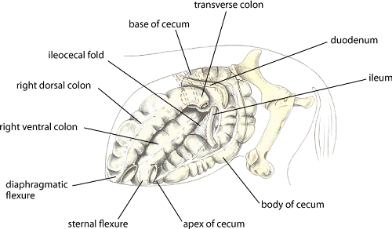
Left medial view of cecum and right colon, horse. Illustration by Dr. Gheorghe Constantinescu.

Fig. 2
Base of cecum, horse
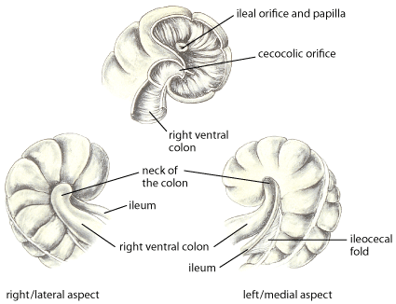
Base of the cecum in the horse. Illustration by Dr. Gheorghe Constantinescu.

Fig. 3
Equine gastrointestinal anatomy
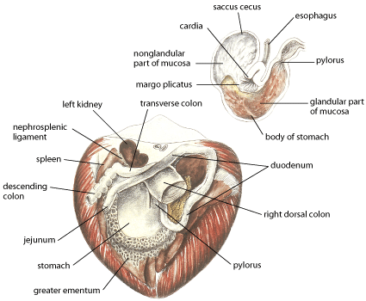
Equine GI anatomy relevant to colic, median section. Illustration by Dr. Gheorghe Constantinescu.

The diameter of the dorsal colon is largest either at its diaphragmatic flexure or in the right dorsal colon. There are no sacculations in either the left or right portion of the dorsal colon. The right dorsal colon is closely attached to the right ventral colon by a short intercolic fold and to the body wall by a tough, common mesenteric attachment with the base of the cecum. In contrast, neither the left ventral nor left dorsal colons are attached directly to the body wall, allowing these portions of the colon to become displaced or twisted.
Ingesta moves from the large right dorsal colon into the short transverse colon, which has a diameter of ~10 cm and is fixed firmly to the most dorsal aspect of the abdominal cavity by a strong, short, fibrous mesentery. The transverse colon is located cranial to the cranial mesenteric artery. Finally, the ingesta enters the sacculated descending colon, which is 10–12 ft (3–3.6 m) long.
Fig. 4
Large intestine, horse
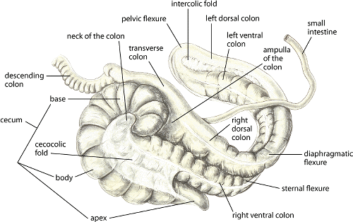
The large intestine of the horse. Illustration by Dr. Gheorghe Constantinescu.

BLOOD SUPPLY TO THE GI TRACT
The celiac and cranial mesenteric arteries (branches of the abdominal aorta) supply blood to the GI tract. The celiac artery supplies arterial blood to the stomach, pancreas, liver, spleen, and the first portion of the duodenum. The cranial mesenteric artery supplies arterial blood to the remaining portion of the duodenum; to all of the jejunum, ileum, cecum, large colon, and transverse colon; and to the first portion of the descending colon. Because the large colon is attached to the body wall only in the region near the cranial mesenteric artery, the blood supplying all portions of the colon must traverse the entire length of the colon. The pelvic flexure receives its blood supply from two branches of the cranial mesenteric artery; one branch supplies the right and left dorsal colons before reaching the pelvic flexure, and the other branch supplies the right and left ventral colons before reaching the pelvic flexure. Thus, volvulus of the large colon near the junction of the colon and cecum may impede the flow of blood to the entire left colon.
The major branches of the cranial mesenteric artery can be damaged by the migrating forms ofStrongylus vulgaris (see Large Strongyles in Horses).
NATURAL OPENINGS IN THE ABDOMEN
Kidneys and spleen, horse
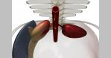

Renosplenic ligament, horse
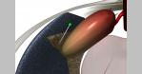
There are several natural openings or spaces within the abdominal cavity that can be important in conditions causing colic. The inguinal canal provides an opening through which intestine might pass and become trapped. Although inguinal hernias are common in young foals, they rarely cause clinical problems; the situation is considerably different in stallions. Similarly, if the ventral abdominal wall fails to form properly around the umbilicus, an opening remains and the potential exists for intestinal problems to develop secondary to an umbilical hernia. The epiploic foramen, a natural opening between the portal vein, the caudal vena cava, and the caudate lobe of the liver, can be the site of intestinal incarcerations. Finally, there is a natural space between the dorsal aspect of the spleen and the left kidney. This space is bounded by the renosplenic ligament, a strong band of tissue that connects the dorsomedial aspect of the spleen with the fibrous capsule of the left kidney. This ligament provides a “shelf” over which large colon can be displaced.
Fig. 5
Nephrosplenic ligament, horse
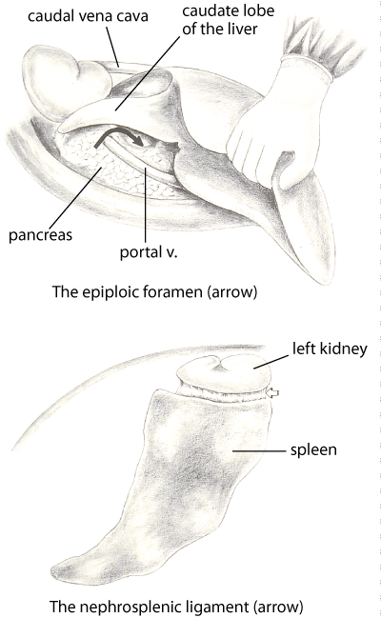
Nephrosplenic ligament in the horse. Illustration by Dr. Gheorghe Constantinescu.

Fig. 6
Umbilicus, horse
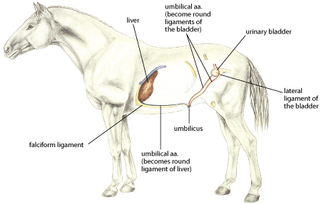
Umbilicus in the horse. Illustration by Dr. Gheorghe Constantinescu.

Fig. 7
Inguinal hernia, horse
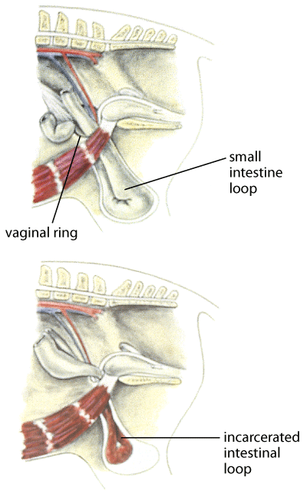
Inguinal hernia in the horse. Illustration by Dr. Gheorghe Constantinescu.

Fig. 8
Inguinal canal, horse
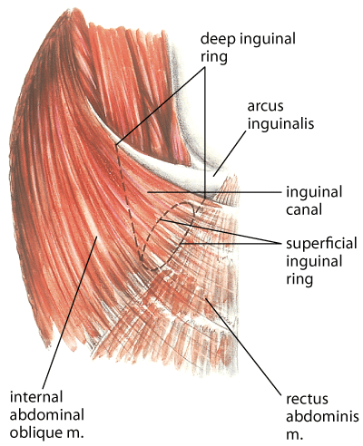
Inguinal canal in the horse. Illustration by Dr. Gheorghe Constantinescu.

COLONIC MOTILITY PATTERNS
Normograde peristalsis in the left ventral colon moves ingesta toward the left dorsal colon, and the muscles in the wall of the left dorsal colon contract to move the ingesta toward the diaphragmatic flexure. There is evidence, however, that the muscles in the left ventral colon contract in a retrograde fashion, from the pelvic flexure region toward the sternal flexure. Furthermore, these contractions appear to originate from a pacemaker region in the pelvic flexure. It has been hypothesized that this pacemaker senses either the size or the consistency of the feed particles in the ingesta and then initiates the appropriate motility pattern. If the ingesta has been digested sufficiently, it is moved in a normograde direction; if additional digestion is necessary, the ingesta is moved in a retrograde direction to retain it in the ventral colon. This theory has been proposed to help account for the common clinical occurrence of obstruction at or near the pelvic flexure.
Stretching position, colic
