Intra-Operative Procedure
After the site was prepped, the distal portion of the scrotum was grasped and pulled distally, thus displacing the testes proximally. The distal third of the scrotum was excised and the testes pushed downwards, exposing the testes.
Picture 1 Showing excision of the testes.
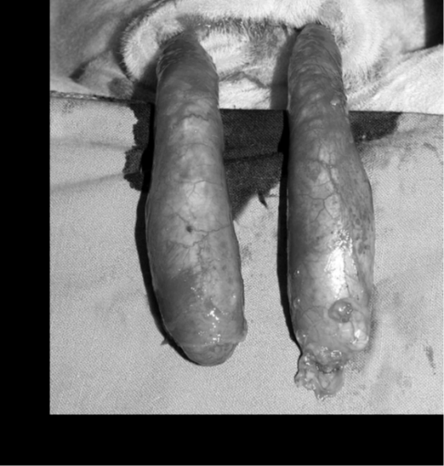
Picture 2 showing exposed testes Picture 3 showing freed spermatic cord
Traction was applied to each testis, and the spermatic cord is freed by stripping the fascia away from the testes proximally. At this point the spermatic cord was clamped with a haemostat and a one handed surgical ligature was place right above the clamp (see one handed ligature video). After the ligature is secured, an emasculator was used to transect and crush the spermatic cord distally to the clamp and ligature. The emasculator is placed on the spermatic cord with the Knot of the emasculator towards the testes of the animal (knot to nut) and the handles are pressed down all the way 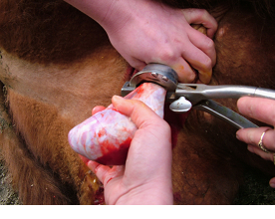
Picture 4 showing the use of an emaculator to transect the spermatic cord
Testes have been transected and fall away and the handles were held for about a minute after to ensure that proper haemostasis and blood clotting has occurred. The emasculator is removed and the clamp is slowly removed ensuring that the clot has properly formed and no bleeding has occurred. The scrotom is left unsutured to facilitate drainage.

