Caslick's Vulvoplasty Operation:
Treatment should be directed at correcting the cause of pneumovagina and concurrently treating the resulting acute endometritis. The former can be done surgically by Caslick's operation although in some cases increasing the physical condition and fat status of the mare may be sufficient. This is the most common surgical procedure performed in studfarm practice, but in the author's opinion some mares are subjected to Caslick's operation unnecessarily. The operation should be reserved for mares with a true vulval defect rather than just because the mare has failed to become pregnant.
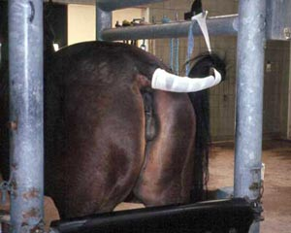  Figure 8:  Restraint and careful preparation of the mare. | 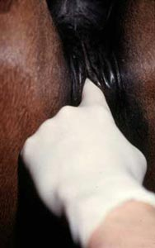  Figure 9:  The level of the pelvis floor is determined. | 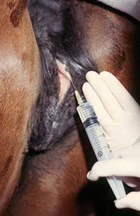  Figure 10:  Infiltration of local anaesthetic.

The mare should be suitably restrained ideally in a set of stocks, her tail bandaged and her vulva thoroughly cleaned and dried (Figure Eight). With a gloved hand, the level of the floor of the pelvis is determined (Figure Nine). This allows you to ascertain the level to which the dorsal commissure of the vulva must be sutured. Beginning at this level, the mucocutaneous junction of the vulva is infiltrated with local anaesthetic through a 21-gauge one-inch needle (Figure Ten).
It is important to use plenty of local anaesthetic and in many cases at least 25 ml will be needed. The local anaesthetic helps to evert the mucocutaneous junction. Both sides of the vulva are infiltrated in a stepwise fashion proceeding dorsally up to the dorsal commissure being sure that enough local is put right at the dorsal extent of the vulva. For mares operated on previously it is important to infiltrate deeply. This can be difficult due to the considerable amount of scar tissue often present in mares which have had repeated Caslick operations.
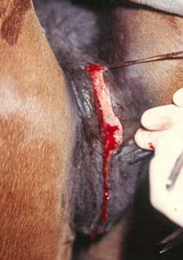  Figure 11:  Removal of a very narrow strip of mucosa. | 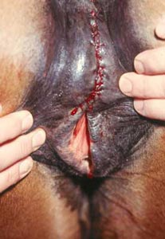  Figure 12:  The submucosal tissues are sutured together.

