CASLICK’S VULVOPLASTY:
Caslick’s vulvoplasty was first described by Dr. E. A. Caslick in 1937 and involves apposition of the vulval lips. Local anesthesia of vulval lips, removal of a thin portion of mucosa from the mucocutaneous junction, and apposition of the cut edges is simple, quick, and effective. Length of apposition is determined by height of the pelvis relative to vulval lips. In general the join should continue to a point at least 3 to 4 cm below level of the pelvis, and approximately 3 cm should be left unopposed to allow for urination.

POINTS FOR CONSIDERATION:

• For suture material we use 0 catgut (Metric 4) on a continuous spool. The benefit of gut is that it is gone or degraded by either pregnancy testing (∼15 days) or the next breeding cycle (if the mare is empty). Other materials that are nonabsorbable or delayed-absorbable may injure the stallion if the mare is rebred.
• For suture pattern, a simple continuous pattern is quicker than and just as effective as a simple pattern interrupted. However, failure to appose the deepest layers of the exposed tissues may result in fistula formation. Failure to exit/enter in the middle of the cut tissue caused by taking bites too deep will result in wound breakdown.

Method of mucosa removal:

• Tissue should be removed from the mucosal surface of the vestibule, not the skin of the vulva lip.
• Removing too much will result in fibrosis and difficulty for the next veterinarian.
• If multiple procedures are performed in 1 season, freshening with a scalpel blade is sufficient, provided a careful suture pattern is placed.
• Incision with a scalpel blade rather than mucosal removal is recommended for maidens (i.e., race mares). This results in a thinner join that is easily opened at the breeding farm.

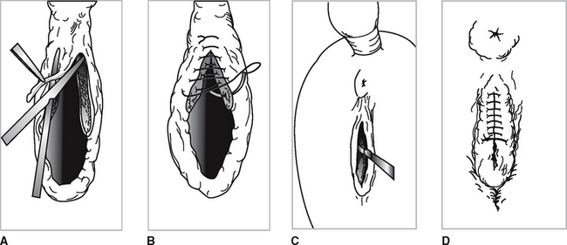
Figure 1.A, Careful trimming of the mucocutaneous junction without removing skin from the vulval lips facilitates many more identical surgeries. B, Simple continuous suture is all that is necessary, but suture placement will help avoid fistulas. C, A scalpel blade is recommended for the first Caslick a mare has, especially maidens in work. D, A breeding stitch may be useful in preventing the Caslick from opening with vaginal examination or natural service.

Postoperative treatment:
• Frequent rectal palpation within 2 weeks will result in fistula formation.
• Remove (open) 2 to 3 weeks before anticipated foaling.

