Bandages are useful for:
- Provide wound cleanliness
- Control the wound environment
- Reduce oedema and haemorrhage
- Eliminates dead space
- Immobilize injured tissue
- Minimizes scar tissue
- Keeps wounds warm which improves wound healing and facilitates oxygen dissociation
- Promotes an acid environment by preventing CO₂ loss and allowing absorption of ammonia. An acid environment increases O₂ dissociation from haemoglobin and subsequently increases oxygen availability in wounds
- Should be comfortable and clean to prevent patients from mutilating them
- Pressure should be applied over and distal to the wound (NOT proximal) so that venous and lymphatic drainage is not compromised
- Should be changed according to type of dressing and wound to prevent strike through and slippage but still allowing adequate time for healing

Notes: Apply bandage on clean dry legs; Apply correct tension; make wraps smooth and even; provide adequate padding.

Bandage Layers
Layers | Materials | Description
- Primary Layer (Contact/ dressing)  This layer can be:  - Dry-dry – used on wounds with loose necrotic tissue & debris w/ large quantities of low viscosity exudate  - Wet-dry – used on wounds during debridement phase. This layer assist in debridement by liquefying coagulum & absorbing necrotic debris while leaving viable tissue intact.  - Wet-wet – similar to wet-dry except the contact layer is not allowed to dry before removal. Used on wounds w/ large amts of viscous exudate & little debris/ necrotic tissue | - Non-stick material for clean wounds  OR  - Gauze material for debridement | - Touches the wound surface and remains in contact with it during movement.  - Debrides tissue, delivers medication, transmits wound exudate/ forms an occlusive seal over wound.  - Should minimize pain and prevent excess loss of body fluids.  - May be adherent/ non-adherent AND occlusive/ semi-occlusive.
- Secondary Layer (Intermediate/ absorptive) | - Materials that absorb and retain discharge (Cotton; gauze) | - Absorbs and stores deleterious agents  - Should not allow fluid evaporation  - Should allow capillarity  - Should b thick to collect sufficient fluid.  - Pads wound from trauma  - Holds contact layer against wound.
- Tertiary Layer (Outer wrap) | - Vetrap/ Surgical tape | - Protects from external contamination

Splints:
Splints can be incorporated into bandages to help immobilize a wound. They can be made from boards, polyvinylchloride (PVC) pipe, heated and molded PVC, or fiberglass casting tape. Properly applied splints offer immobilization that is superior to bandaging alone but inferior to casting. The major benefit of splints is that they can be readily changed by owners who have been properly instructed.
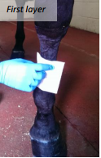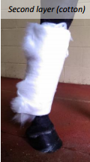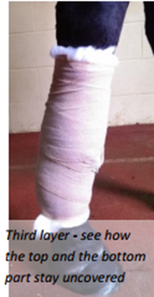

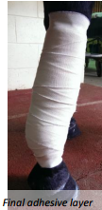

BANDAGE COMPLICATIONS:
Signs relating to bandage complications:

• Swelling develops above the bandage. • Showing increased lameness.
• Stamping the bandaged leg. • The bandage feels wet.
• Discharge can be seen through the bandage layers. • Patient interferes with the bandage (i.e chewing).

