Fracture levels of forelimb and hindlimb and methods of immobilization:

Level 1
Injuries requiring immobilization include fractures of the phalanges (which include the long pastern bone and the short pastern bone but not the coffin bone), proximal sesamoid bones, and distal end of the cannon or metacarpal/tarsal bone. Luxation of the phalangeal bones and injuries to the flexor and extensor tendons.
Immobilization: Can be done using a Kimsey Leg Saver or a splinted Robert Jones bandage. On the forelimb the limb is bandaged from the point of the toe to the proximal metacarpus and palmer and lateral splints are applied to provide further stabilization. In the hindlimb a splint can be applied to the plantar surface of the foot from the point of the toe to the hock. Splints may be made out of Polyvinyl chloride (PVC) pipes as they offer good rigidity and may be cut to conform around the horses leg.
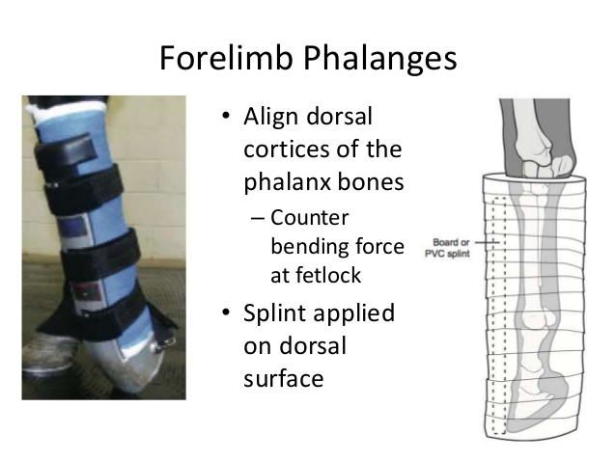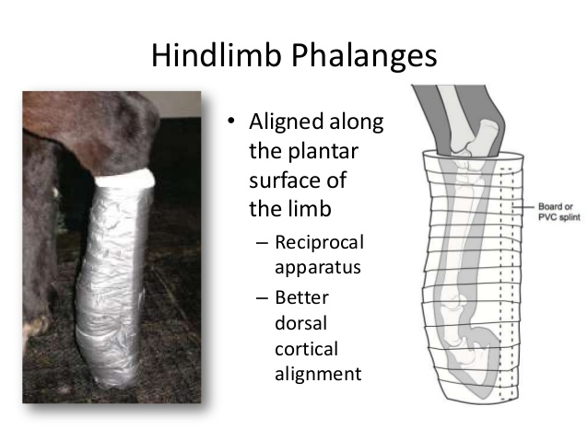

Level 2
Injuries include mid to proximal metacarpal and metatarsal bone fractures, carpal bone fractures, distal radial fractures, and wounds of the carpus.
Immobilization: It is best to stabilize forelimb fractures using a Robert Jones bandage with rigid PVC splints on the caudal aspect and lateral aspects of the leg; duct tape can be applied to prevent splint movement when the horse bears weight on the limb. The finished splint and bandage should extend from the horse's toe to elbow and should be roughly three times the diameter of the limb at the fracture site.
In hindlimb injuries, as in the forelimb, the bandage should be 3 times the diameter of the limb and extend from the floor to the stifle. Two splints are again needed. A lateral splint extending from the floor to the stifle and a caudal splint extending only to the point of the hock because of interference with the reciprocal apparatus and the angulation of the hock.
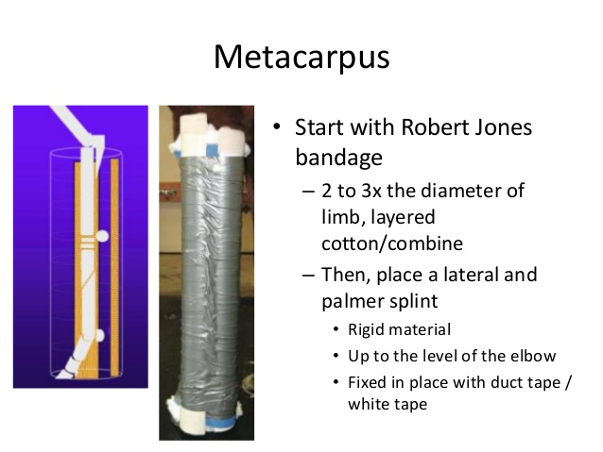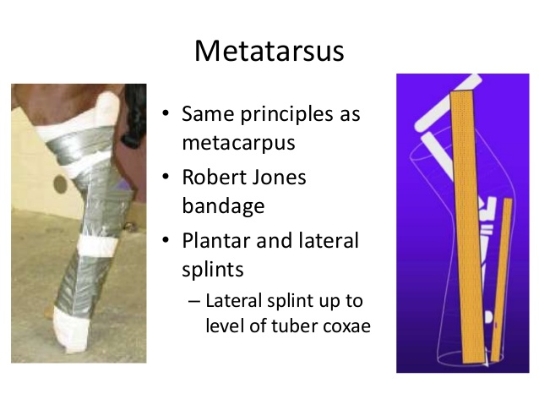

Level 3
These injuries extend from mid to proximal radius or tibia. The limb tends to abduct and this can often lead to open fractures if bones puncture through the skin; to avoid this it is important to splint the limb correctly.
Immobilization: The limb is first bandaged using a Robert Jones with caudal and lateral splints in the forelimb. The lateral splint should extend from the ground up the side of the chest to the withers. In the hindlimb only a lateral splint is used and this extends from the ground to the tuber coxae.

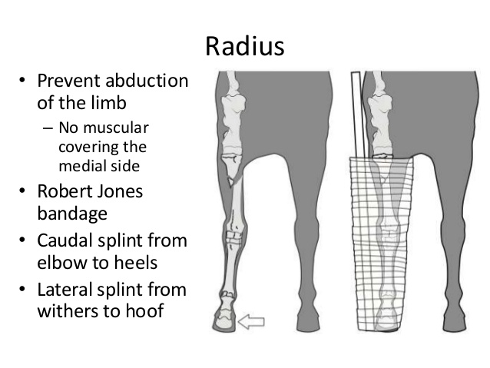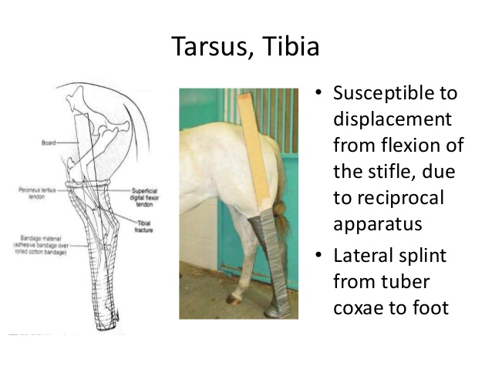

Level 4
Level 4 injuries include fractures of the scapula, humerus, femur, and pelvis.
Immobilization: For forelimb fractures a level 2 bandage and a caudal splint from the ground to the elbow is used to fix the carpus in extension. Although the fracture is not directly stabilized by this splint, it will prevent tendon contraction and allows the horse to reduce weight bearing on the leg. Bandaging and splinting are not indicated for fractures of the hindlimb at level 4 as the joint above and below the fracture cannot be immobilized, preventing fracture stabilization.

