**Physical Restraint:**

Always at least some minimum form of restraint required.

1. Minimum restraint required: halter and lead rope
   * A PE should never be attempted without a halter and lead rope in place with someone holding the horse.
   * Never wrap lead around your hand, arm or any other body part
   * Never tie a horse unless you know it is accustomed to being tied.
2. Chain over nose Provides additional restraint
3. 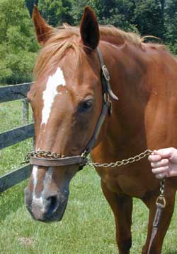
4. A lip or gum chain is more severe, and is often used on breeding stallions. 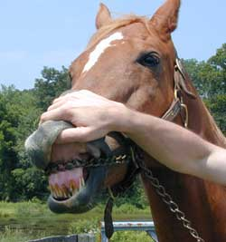
5. Twitching with hand
   * Neck twitch
   * 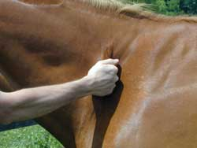
   * Nose twitch
   * Ear twitch
   * 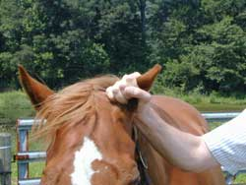
6. Twitching with device
   * Different types -
     + wood with rope ; less severe than...
     + wood with chain
     + metal
7. Applying twitch - firmly grasp muzzle with fingers through loop 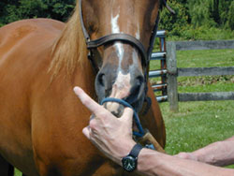 place loop over end of nose and twist the stick. 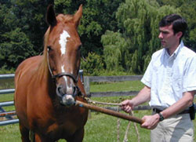 May be tightened or loosened as appropriate.
8. Considerations -
   * NEVER let go of twitch--can swing and injure you, handler, or horse
   * Size counts--the longer the twitch, the more control
   * Do not leave twitch on too long--may cause damage or become ineffective.
   * Never put twitch device on ear--if you feel this may be necessary, consider chemical restraint.
9. Lifting a limb
   * May be helpful to allow examination of weight-bearing limbs. Use with caution--horses are stronger than you are.
10. Crossties
    * Appropriate for grooming but generally crossties or tying a horse is not recommended while conducting a physical exam
    * Definitely not for painful or bothersome procedures
11. Stocks
    * Very helpful for rectal exams and reproductive evaluations.
    * Not foolproof--horses may try to jump out or go down

**Rectal Exam Restraint Considerations**

* Over half door --may protect from kick but if horse goes down, you lose your arm.
* Around corner --safe but may lose some reach.

**Verbal Restraint**

Talking to horses has a major effect. A soothing, reassuring tone goes a long way in calming a fractious horse. Similarly, a sharp authoritative tone accompanied by a tug on the lead rope may help keep a fidgety horse in place.

**Chemical Restraint**

Do not be afraid to use chemical restraint. (However, use of chemical restraint may alter some PE findings--heart rate, etc. So if you are planning on using chemical restraint, attempt general physical exam first.) Can be used alone or with other techniques or devices. Consider animal's weight, age, health, and task to be performed when considering chemical restraint and agent(s) to be used. Select and dose appropriately.

**Foals--special consideration**

Very different than adults--they lack training and experience so the commands, techniques, and devices used in adults are often ineffective and potentially dangerous.

Best method of foal restraint

Arm in front of chest and arm behind rump while grabbing tail

NEVER pull on foal's head

NEVER tie a foal.