PRIMARY LAYER:
- This layer contacts the wound and allows fluid to pass to the secondary layer.
- It remains in contact with the wound.
- It may debride (remove of dead tissue to promote healing and increases the healing duration) tissue, deliver medication, transmits wound exudate or forms and occlusive seal over the wound.
- Should minimize pain and prevent loss of excess fluids
Can be non- adherent: Repair phase; indicated when a healthy granulation bed has developed. This layer prevents tissue desiccation and causes minimal trauma.
Can be adherent: Debridement phase; uses a wide mesh material that allows tissue and debris to become incorporated into the bandage. This debris is then removed with the bandage change. Adherent bandage may be of the following types:
- Dry-dry- for copious amounts of dilute/watery discharge. The bandages are painful to remove but enable excellent tissue debridement.
- Wet- dry- for moderate amounts of fluid discharge; most common type of adherent in vet med - contact layer is initially wet & debrides wound while drying. They are also painful to remove but result in less tissue desiccation than dry-to-dry bandages
- Wet- wet- for copious amounts of viscous discharge; contact layer remains wet; has little debriding capacity. Wet-to-wet bandages tend to damage the tissue bed by keeping it too moist. Newer bandage materials may be impregnated with various materials, such as silver, to help control infection.
Can be hydrophilic- All phases of wound management.
- Manages moderate to heavy wound exudate
- Maintains a moist wound healing environment
- Draws fluid from the wound which are bathed into dressing
- Permits gaseous exchange
- Provides thermal insulation
- Protects from secondary infection and contamination
- Allows for pain free removal at dressing changes
SECONDARY LAYER
- Absorbs and stores deleterious agents
- Should not allow fluid evaporation
- Should allow capillarity and be thick to collect sufficient fluid
- Pads wound from trauma (shock absorbent)
- Splints to prevent movement (stabilising)
- Holds contact layer against the wound and itself against the contact layer

TERTIARY LAYER
- Protects from external contamination
- Also keeps the previous 2 layers together
- May be : adhesive, cohesive (sticks to itself without glue) or non-adherent

Bandage Level | Subcategory | Materials and examples
Primary | Adherent: Dry- dry | Usually gauze swab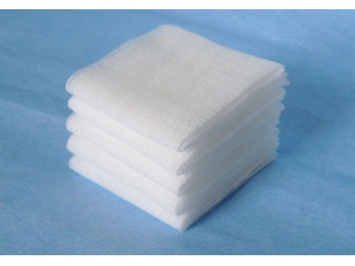
 | Adherent: Wet- Dry | Gauze swab moistened with saline water
 | Adherent: Wet- wet | Gauze swab injected with saline via a drain
 | Non- adherent | Melolin 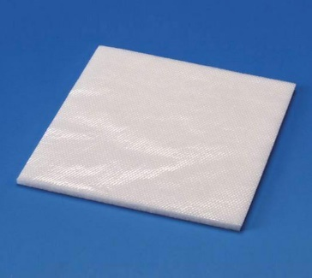
 |  | Jelonet 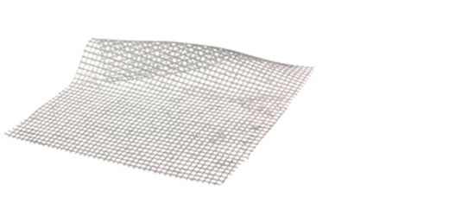
 |  | Allevyn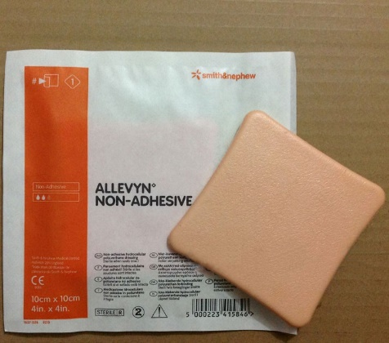
 | Hydrophilic | Intra-gel 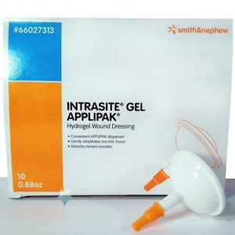
Secondary |  | Cotton wool; Gamgee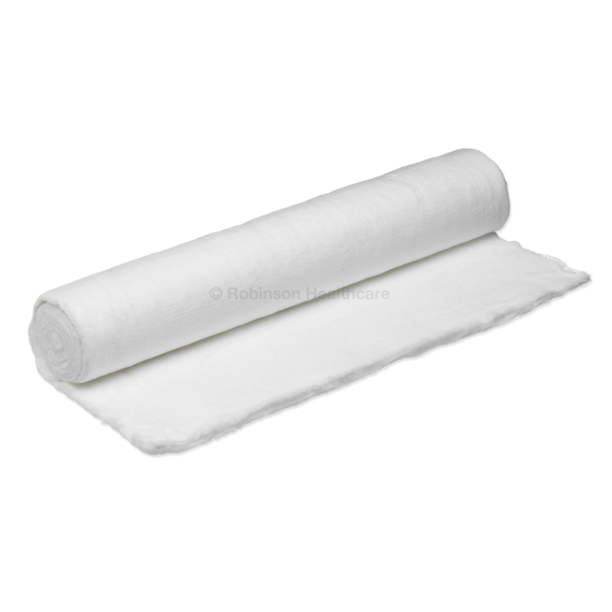
 |  | Disposable nappy
Tertiary | Cohesive | Vetrap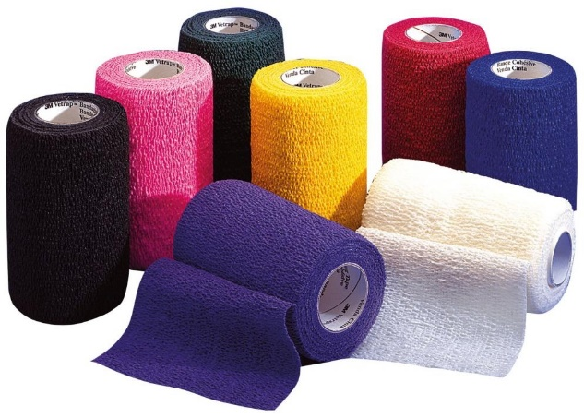
 | Adhesive | Elastoplast 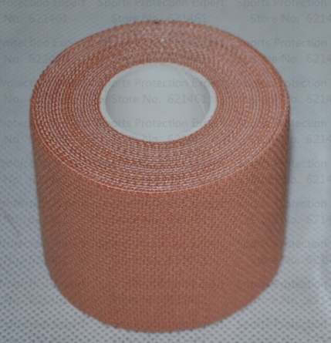
 | Non-adherent | Crepe bandage 