SUPERIOR CHECK LIGAMENT

DESMOTOMY

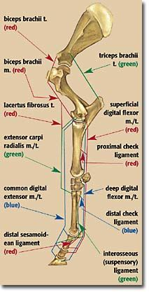

**INDICATIONS**

1. Chronic Superficial Digital Flexor Tendinitis
2. Conformational defects of Carpus
3. Flexural deformities causing Knuckling

****Transection of the accessory/superior check ligament allows the muscle-tendon unit to lengthen, extending stride and range of motion.

**PROCEDURE**

* Make a 10cm incision is made between the cephalic vein and the caudal border of the radius, centered next to the chestnut and extending from the medial distal physis of the radius proximally, directly over the flexor carpi radialis tendon
* Use sharp dissection through the subcutaneous tissue until the perforating branch of the cephalic vein and its oval foramen in the antebrachial fascia are identified
* Ligate the branch to aid caudal retraction of the cephalic vein
* Incise the antebrachial fascia 1cm caudal to the radius, exposing the tendon of the flexor carpi radialis within its sheath
* Conduct haemostasis
* Incise the fascia and use forceps to guard the tendon, opening the sheath about 6-8cm
* Retract the tendon caudally exposing the deep aspect of the sheath
* Insert curved Kelly forceps through the sheath and under the border of the ligament and spread
* Carefully transect the sheath and the ligament over forceps in a proximal direction (ensure the proximal portion of the ligament is properly transected and avoid severing the nutrient artery and vein and the palmar carpal rete vessels)
* Lavage, suction and do final haemostasis
* Close the first layer with interrupted sutures (tendon sheath), the second with simple continuous (subcutaneous layer) and the final with simple interrupted sutures (skin)
* Apply a sterile heavily padded pressure bandage to the foot up to above the incision site (especially if proceeding to the other leg or if moving to recovery)

**POST-OP**

Healing scar is devoid of functional elasticity. The ligament heals with a more proximal attachment to the tendon.