MEDIAL PATELLAR LIGAMENT DESMOTOMY

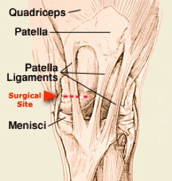

**INDICATIONS**

1. Proximal Patellar Hesitation
2. Upward Patellar Fixation (may be intermittent or persistent – do only after unresponsiveness to conservative therapy)

**PROCEDURE**

* Make a 1cm incision just lateral to the medial patellar ligament close to the tibial tuberosity (palpable depression)
* Blunting dissect through the heavy fascia positioning the curved Kelly or Crile haemostat deep to the desired ligament
* Pass a blunt curved tenotomy knife through the fascia and behind the ligament without penetrating the joint capsule
* Rotate the knife so the cutting edge is against the ligament and sever the ligament (the stifle should drop slightly as the patella is released)
* Close the skin with a few sutures of non-absorbable non-capillary material

Be weary of the medial collateral ligament of the femoro-tibial joint