INFERIOR CHECK LIGAMENT

DESMOTOMY

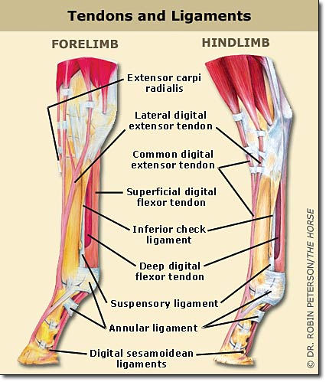

**INDICATIONS**

1. Deep Digital Flexure Tendon Contracture “Club Foot”
2. Caudal Foot Lameness
3. Flexural Deformities (foals aged 2-8 months unresponsive to conservative therapy)
4. Secondary to Chronic Excessive Trimming of Steeply-Angled Hooves (attempt to balance feet)

****Transection of the distal/inferior check ligament allows the muscle-tendon unit to lengthen, extending stride and range of motion.

PRESENTING SIGNS – Chronic intermittent lameness, poor performance, shortening of stride etc.

**PROCEDURE**

This can be approached from the medial or lateral aspect, with special care being taken if using the medial approach as the neurovascular bundle is in that same region.

* Palpate the ligament immediately palmar to the dep digital flexor tendon and make a 5cm long skin incision over the tendon in the proximal metacarpal region at that level
* Use blunt and sharp dissection to separate the deep digital flexor tendon and the distal check ligament, elevating the ligament using a curved forceps.
* Confirm the location of the suspensory ligament and the superficial and deep digital flexor tendons
* Sharply transect the distal check ligament and extend the toe
* Remaining fibers of the ligament should be transected and the resulting gap palpated
* Close the incision and apply a sterile bandage
* Corrective shoeing and trimming can be done now but preferably before surgery as this is vital to long-term success of the procedure

**POST-OP**

The gap will fill with fibrous tissue and there may be a cosmetic blemish (the risk and size of blemishing increases over 1-year-old). Prognosis is dependent on the severity of the presenting problem and the age of the foal/horse at the time of surgery.