BANDAGING PRINCIPLES

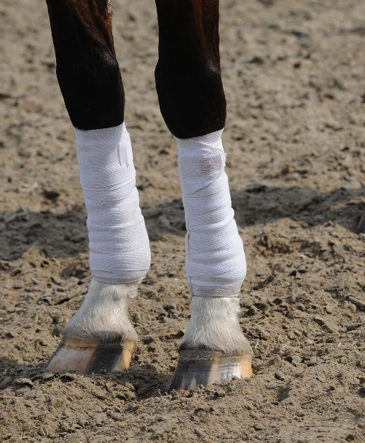

Regardless of the type and purpose of the bandage, there are several basic principles that are of critical importance when it comes to bandaging your horse’s legs safely and effectively.

**1. Begin with clean, dry legs and bandages.**Trapped beneath the bandage, dirt and debris can cause skin irritation and infect the wound (if one is present), while moisture can lead to a fungal infection.

**2. Apply correct tension.** The best tension should allow the bandage to fit snug i.e. tight enough to remain securely in place but not so tight as to restrict blood flow. If it is too loose then it won’t provide sufficient support and may exacerbate injury. If it is too tight it may result in tendon injury or blood loss.

**3. Make wraps smooth and even.**The bandage and the padding underneath should lie flat and smooth, without any wrinkles, bunches, or ridges that could cause pressure points. Leg bandages are wrapped in a spiral pattern, and each wrap you make around the leg should overlap the preceding layer by about 50 percent to ensure consistent, even distribution of pressure.

**4. Provide adequate padding*.*** An inadequate amount of padding between the bandage and the limb can result in constriction on the limb, inhibiting blood flow and creating pressure points that can lead to injury. As a general rule, the layer of padding should be at least one inch in thickness in order to adequately cushion and protect the leg. Always make sure there is about an inch of padding showing above and below the bandage.

**5. Wrap from front to back, outside to inside (counter-clockwise on left legs, clockwise on right legs).** This ensures tension from the bandage is applied to the front of the leg rather than on the delicate tendons at the back of the leg.

**6. Start the wrap over bone at the inside front of the leg.** Never start or finish the wrap over the tendons, which may cause damage, or over a joint, as the constant movement will loosen the bandage and may cause it to bunch or unravel.

**7. Wrap legs in pairs.** While it isn’t necessary to wrap all four legs, standing bandages and exercise bandages should always be applied to both front legs, or both hind legs.

**8. Check leg bandages frequently and re-bandage if necessary*.*** As a general rule, standing bandages should not be worn for longer than 12 hours at a time, while wound bandages should usually be changed every day.