Laminitis
Laminitis is a painful inflammatory condition of the tissues (laminae) that bond the hoof wall to the pedal (coffin) bone in the horses hoof. It can affect any horse, of any age or sex, at any time of the year.

Navicular disease
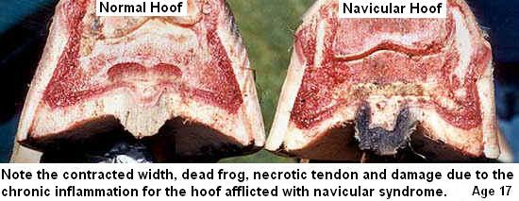
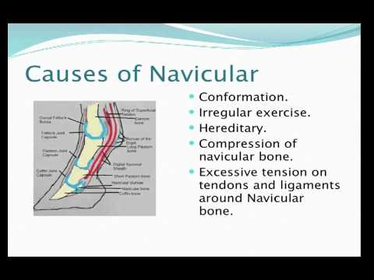
Azoturia
