**DRUGS**

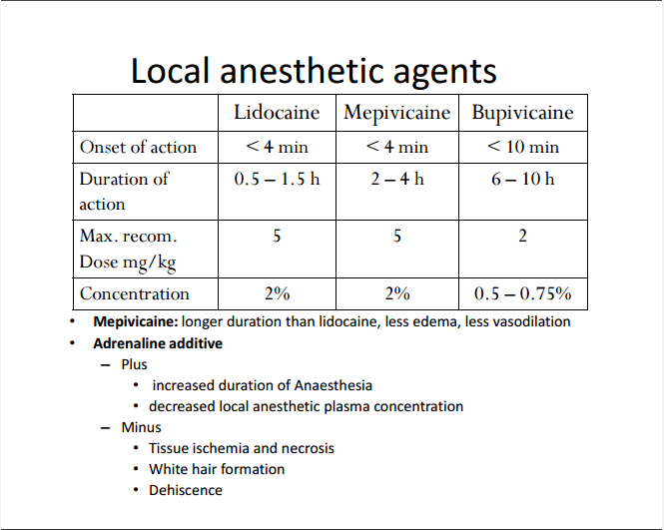

How do local anesthetics work?

– Nerves require Na+ influx from extracellular to intracellular

– Binds and blocks the Na+ gated channels on the neuronal cell membrane

– No influx of Na+ from extracellular to intracellular • No depolarization

– Can be coupled with epinephrine for vasoconstriction • Longer anesthetic • Less bleeding