**HIGH METACARPAL NERVE BLOCK**

|  |  |  |  |  |  |  |
| --- | --- | --- | --- | --- | --- | --- |
| **NERVE AFFECTED** | **NEEDLE** | **VOLUME** | **TECHNIQUE** | **POSITION OF LIMB** | **ONSET TIME** | **STRUCTURES BLOCKED** |
| -lateral/medial palmar nerve  -lateral/medial palmar metacarpal nerve | 25-gauge, 5/8-in | 3–5 mL | ***-High 4-point***: block the palmar nerves between DDFT & suspensory ligament, and block palmar metacarpal nerves axial to the splint bone and abaxial to the suspensory ligament | Standing or flexed | 10-20 minutes | Blocks all structures distal to the carpus, including the proximal suspensory ligament. |
| -lateral/medial palmar nerve | 25-gauge,5/8-in | 5ml  2-5ml | ***-Wheat block:*** accessing the lateral palmar nerve at the groove distal to accessory carpal bone and accessing the medial palmar nerve axial to MC2 (medial splint) adjacent to MC3. | Lateral-standing or carpus slightly flexed  Medial-standing position |
| -lateral palmar nerve | 25-gauge, 5/8-in | 2-5ml | – ***Local infiltration of suspensory ligament:*** Directly infiltrate anaesthesia along axial aspect of splint bones, directly next to the suspensory ligament | Standing or flexed |
| -deep branch of the lateral palmar nerve | 25-gauge, 5/8-in | 2-5ml | – ***Lateral palmar***: Anesthetize the lateral palmar nerve as it courses along the medial aspect of the accessory carpal bone | Standing |

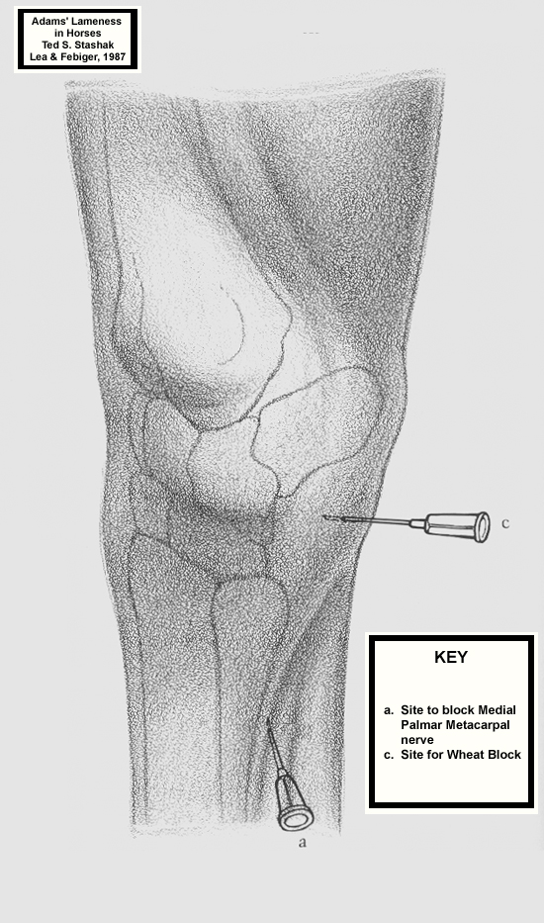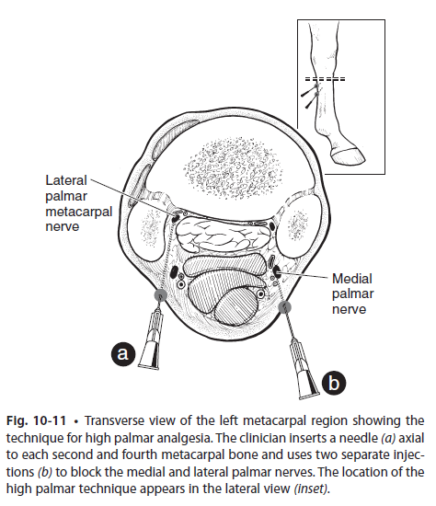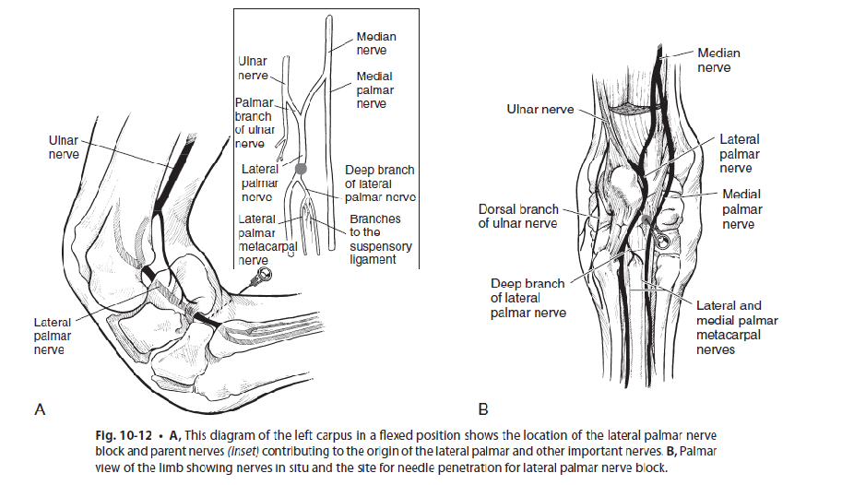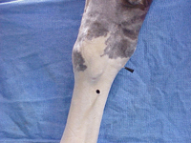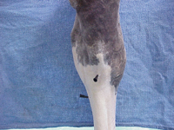

LATERAL VIEW WHEAT 2 POINT BLOCK PALMAR VIEW WHEAT 2 POINT BLOCK