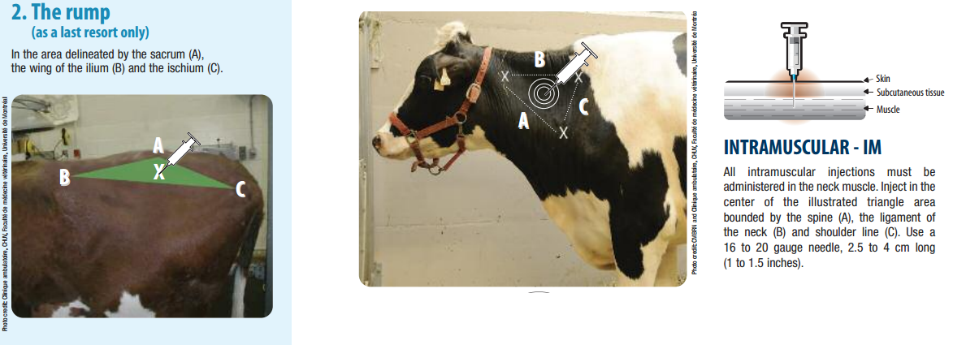

Sites for intramuscular injection in dairy cattle are the Trapezius (neck muscle) and the gluteus (rump). The trapezius was chosen because it was safely away from the hind limb of the cow who was aggressively kicking. The site was cleaned with alcohol. The injection should be given by inserting the unattached needle into the muscle first. This was done by quickly tapping with the back of the hand at the site to distract the cow and inserting the needle into the muscle at the illustrated point. The needle was left there for a few seconds to ensure that no blood was coming out of the hub indicating that a blood vessel was hit and so that the cow could settle down. Then the syringe was carefully attached to the hub of the needle and the drug pushed into the muscle. The needle was removed carefully and the site massaged to distribute the drug.

