CORNUAL BLOCK
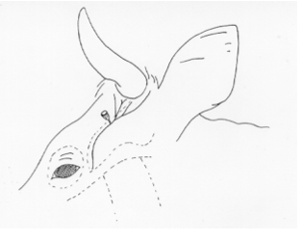

Information:

This block is conducted on the cornual branch of the zygomaticotemporal/lacrimal nerve (a branch of the trigeminal nerve) to prevent sensation to the skin surrounding the base of the horn, and is most commonly done in preparation for dehorning and treating horn injuries. The nerve runs from the base of the ear past the eye ventrally along the facial crest (zygomatic arch). The nerve supplies the horn coruim and the skin around the base of the horn.

Procedure:

Time given – 2:58pm
Route – SC
Onset – 10-15 minutes
Duration – 1 hour

- Insert an 18 gauge needle into the upper third of the temporal ridge, immediately behind the ridge and about 2.5 cm below the base of the horn, to a depth of 0.7 to 1.0 cm. (The nerve may be palpable, between the frontalis and temporal muscles, about half way from the lateral canthus of the eye to a point about 3cm below the lateral base of the horn)
- Attach syringe
- Draw back on the plunger to check that the needle is not placed intravascularly
- Inject the appropriate dosage of 2% lidocaine
- Remove syringe and needle, holding off the area to prevent haematoma formation

N.B.
A blink response should be noted during administration; drooping of the upper eyelid is a good early sign of correct anaesthesia. Failure may occur if the anaesthetic solution is injected too deeply, into the temporal muscle aponeurosis. In large individuals with well-developed horns make a second injection about 1 cm caudal to the first injection, to block the posterior division of the nerve.

