AURICULOPALPEBRAL BLOCK
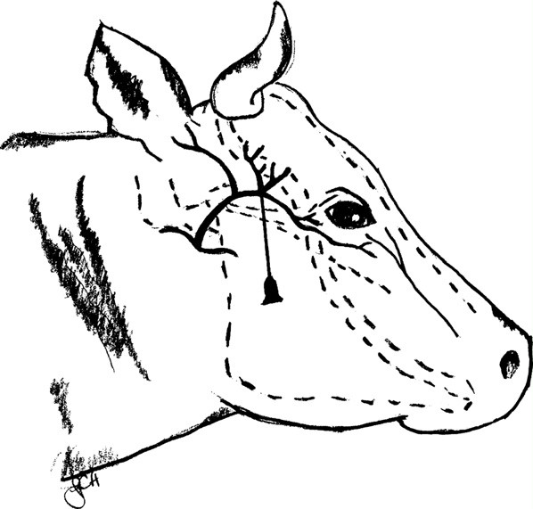

Information:

This block is conducted on the auriculopalpebral branch of the facial nerve to prevent the eyelids from moving (blocks motor activity to the orbicularis oculi muscle), which is important in ocular surgeries or other procedures conducted on the head. The nerve runs from the base of the ear past the eye ventrally along the facial crest (zygomatic arch).

Procedure:

Time given –
Route – SC
Onset – 10-15 minutes
Duration – 1 hour

References
- https://instruction.cvhs.okstate.edu/vmed5412/pdf/14LocalAnesthesia2006b.pdf

