Common Hormone treatments used in large animal medicine:

Trade Name: Fertiline
Drug Name: Gonadorelin Acetate (Gonadotropin Releasing Hormone)
Indicated for use mainly in cattle to aid in reproductive management and in the treatment of cystic ovaries in bovine. Also effective in bovine synchronization programs.
Contraindications: Not to be used in Food animals meant for slaughter. Withdrawal time is 7 days after last treatment.

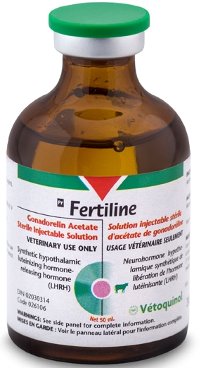

Drug Name: Progesterone 5%
Progesterone 5% Indications:
Hormone for use in Cattle, Swine, Horses, Goats and Sheep experiencing habitual abortions, threatened abortion, nymphomania, sterility, mammary underdevelopment and for oestrous control. To be administered intramuscularly only.
Contraindications: Not for use in Lactating animals as hormone is passed into milk. Not for use in animals meant for slaughter for meat.
Withdrawal: 10 days after last treatment

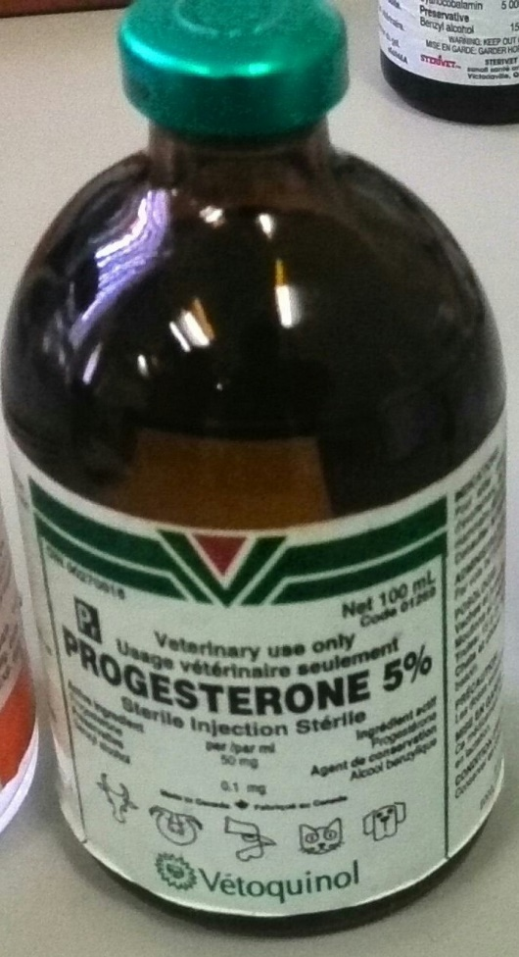

Trade Name: Lutalyse
Drug Name: Dinoprost Tromethamine
Indications for intramuscular use for estrus synchronization, treatment of unobserved estrus and chronic endometritis in cattle; for abortion of feedlot and other non-lactating cattle; for parturition induction in swine; and for controlling the timing of estrus in estrous cycling mares and clinically anestrous mares that have a corpus luteum.
CONTRA-INDICATIONS: For subcutaneous use only in the equine and intramuscular use only in the bovine and porcine. Not to be administered intravenously.
Withdrawal period: No Withdrawal time is noted for dairy milk or meat carded for human consumption however drug should not be used in horses meant for consumption.
