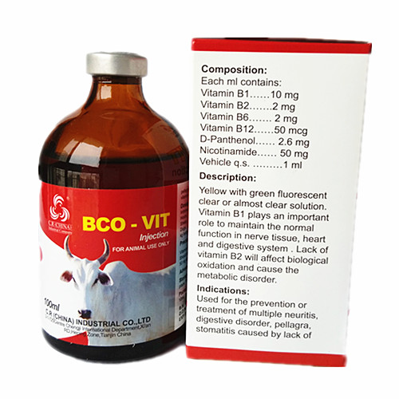
B complex vitamins:
Indications for use in cattle, goats, horses, sheep and swine for the Prevention or treatment of B-vitamin deficiencies in farm animals, Prevention or treatment of stress (caused by vaccination, diseases, transport, high humidity, high temperatures or extreme temperature changes), Improvement of feed conversion.

Contraindications: No major contraindications as B vitamins are usually safe and non toxic.

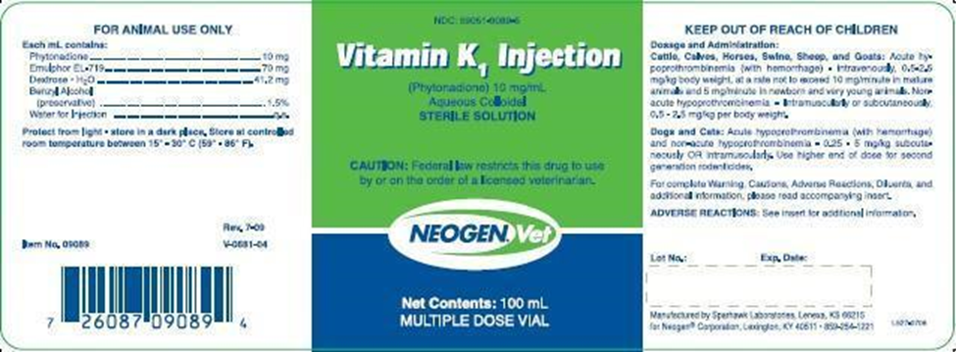
Vitamin K/ Phytonadione
INDICATIONS: ​Vitamin K​1​ Injection is indicated in cattle, calves, horses, swine, sheep, goats for coagulation disorders which are due to faulty formation of factors II, VII, IX and X when caused by vitamin K deficiency or interference with vitamin K activity. Also used to counter Hypoprothrombinemia induced by ingestion of coumarin-based compounds, common ingredients in commercial rodenticides. Vitamin K​1​ Injection is also indicated to counter hypoprothrombinemia caused by consumption of moldy sweet clover.
May be administered via IM or Subcutaneously.
Contraindicated for IV administration due to the severe risk of anaphylaxis leading to shock.
Drug Interactions:
Antagonized when used concurrently with aspirin, chloramphenicol, phenylbutazone and sulfonamides.
Antagonizes the anticoagulant effects of warfarin.
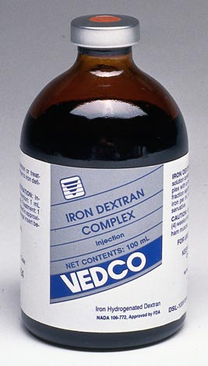
Iron Dextran Complex
Trade names: Ridan, Ferrovall.
Indications for prevention and treatment of iron deficiency anaemia in piglets, calves, foals, pigs, cattle, horses, sheep, goats. It is especially necessary in newborns and animals in anaemic conditions.
Also for Secondary anaemia due to parasitic and bacterial infections, stress conditions (also due to transport), for the betterment of breeding and growth of young animals, supporting treatment of infectious diseases and in blood loss.
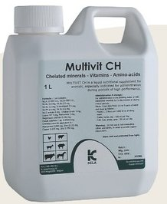
Administered orally into drinking water or milk replacer.
COMPOSITION
Vitamins: Vitamin A eq. 10 000 I.U. - Vitamin D3 eq. 800 I.U. - Vitamin E acetate 4 mg - Vitamin B1 0.8 mg - Vitamin B2 2.0 mg - Vitamin B6 1.6 mg - Vitamin K3 0.6 mg - Nicotinamide 2.4 mg - Dexpanthenol 2.4 mg - Choline citrate 4 mg -
Amino-acids : Lysine Hydrochloride 4 mg - Methionine 2 mg
Chelated trace elements equivalent to: Cobalt 6.7 mcg - Copper 0.035 mg - Iron 0.135 mg - Magnesium 0,028 mg - Manganese 0.650 mg - Zinc 0.450 mg

INDICATIONS for use in Horses, cattle, pigs, sheep, goats for administration during periods of high performance such as during growth; at starting up in young piglets and calves; In case of poor appetite of non-infectious origin and during reproduction and lactation.

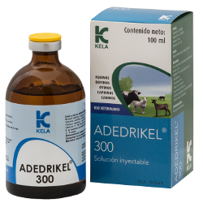
Composed of Vitamin A, Vitamin D3 and E.
Indicated for use in Horses, Cattles, Sheep and goats for the prevention and treatment of deficiencies in Vitamin A and D. Good supplement during periods of high performance.
Contraindicated for use in animals with hypervitaminosis A.
No Noted drug interactions or withdrawal times.

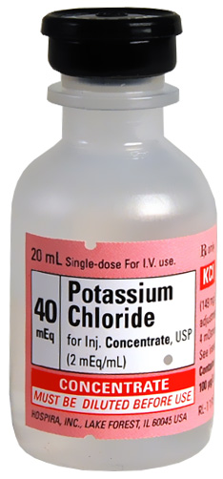
Potassium Chloride injectable solution is diluted and given intravenously or subcutaneously and used to treat or prevent potassium deficiency (hypokalemia) in many animal species

Contraindicated in animals with hyperkalemia (high potassium blood levels), severe kidney disease, acute dehydration, untreated hypoadrenocorticism, or hemolysis. Use with caution in animals with heart disease.

