**DEHORNING TOOLS:**

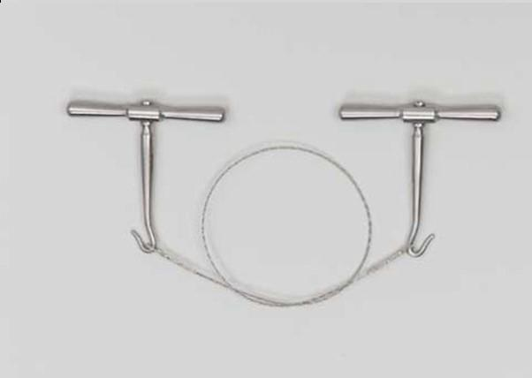

Fig 1: GIGLI wire and handles.

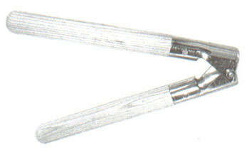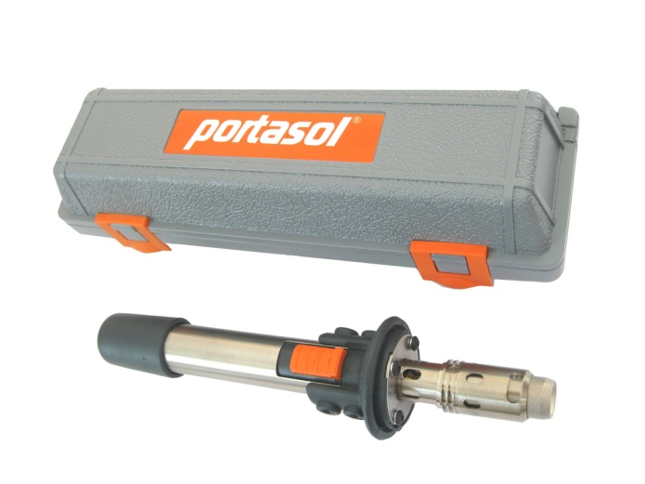

Figs. 2 and 3: Dehorners