**CASTRATION TOOLS:**

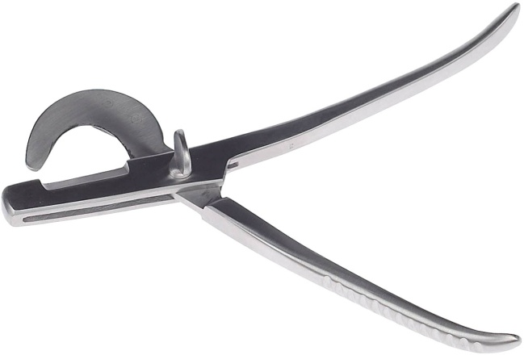

Fig 1: Emasculator

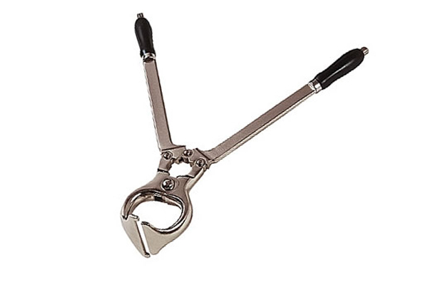

Fig 2: Burdizzo

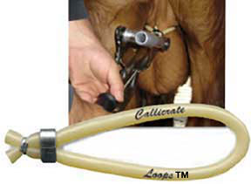

Fig. 3 : Callicrate bander