**RESTRAINT TOOLS:**

**Haussmann’s Mouth Gag:**

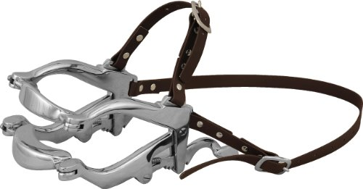

**Nose Punch and Nose Rings:**

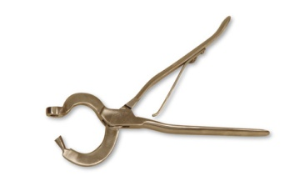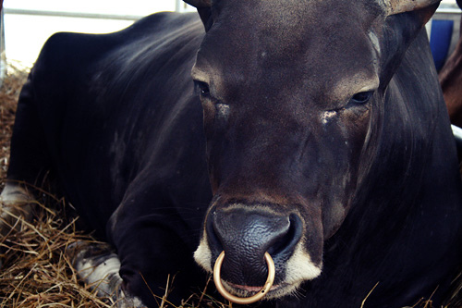

**Electric Goad/Cattle Prod:**

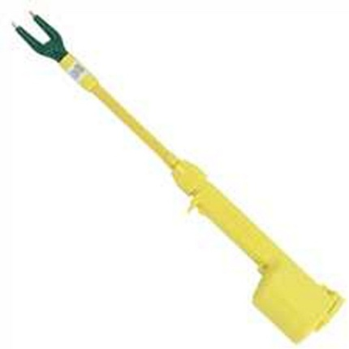

**Hog Snare:**

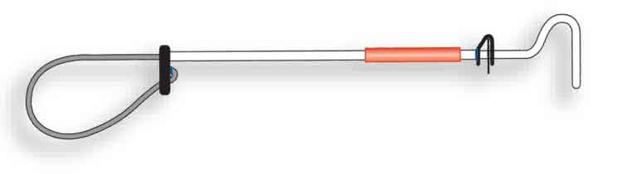

**Cattle Mouth Gag:**

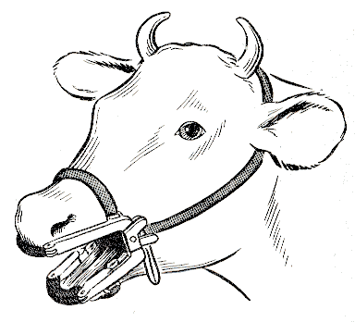

**Anti-Kicking Cow Device**:

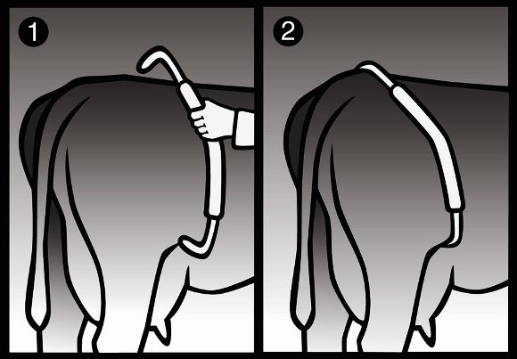

**Twitch:**

