**MAINTENANCE EQUIPMENT:**

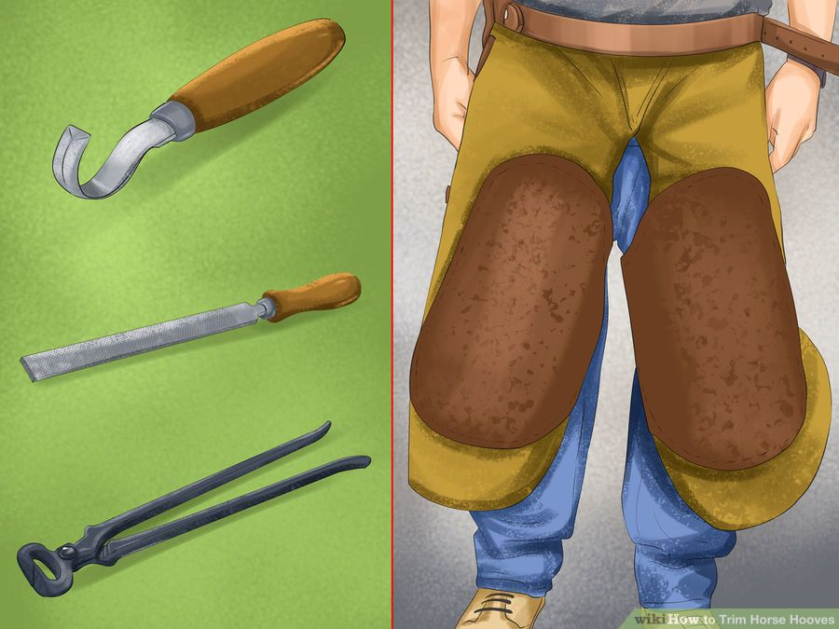

|  |  |  |  |
| --- | --- | --- | --- |
| **Hoof Clipper** | **http://pad3.whstatic.com/images/thumb/a/a1/Trim-Horse-Hooves-Step-7-Version-2.jpg/aid1400584-900px-Trim-Horse-Hooves-Step-7-Version-2.jpg** | * Hoof clippers will be used for the actual trimming of the hoof. | Clippers are similar to large nail clippers for your horse's hooves. The clippers are used to remove excess length in the outer hoof wall. Using the clippers is a good way to quickly remove parts of the hoof, roughly shaping it before finely trimming the remaining areas.   * Place the clippers on any long areas of the outer hoof wall. * Clamp the clippers down to cut the long areas of the hoof wall away. * Work slowly and make sure you are trimming to the length you need. * Trim the front of the hoof at a 45 degree angle to avoid a sharp toe. |
| **Hoof Picker** | **http://pad3.whstatic.com/images/thumb/f/fb/Trim-Horse-Hooves-Step-3-Version-2.jpg/aid1400584-900px-Trim-Horse-Hooves-Step-3-Version-2.jpg** |  | Use your hook knife to remove any dirt or other material that may have become lodged within the hoof. |
| **Hoof Knife** | **http://pad3.whstatic.com/images/thumb/d/dd/Trim-Horse-Hooves-Step-5-Version-2.jpg/aid1400584-900px-Trim-Horse-Hooves-Step-5-Version-2.jpg** | The hook knife can help you dig out any material that is caught in your horse's hoof. | After you have leveled the outer wall of the horses hoof, you will need to trim the sole of the hoof down until it is below the outer wall. This will help keep pressure on the outer wall of the hoof rather than on the sensitive inner sole.   * The outer wall of the hoof should be longer than the sole. |
| **Hoof Rasp** | **http://pad2.whstatic.com/images/thumb/e/e4/Trim-Horse-Hooves-Step-8-Version-2.jpg/aid1400584-900px-Trim-Horse-Hooves-Step-8-Version-2.jpg** | * A rasp is used to level off any rough areas of the hoof. | * As you clean and trim your horses hooves, they may become unleveled or rough in some areas. The rasp is a steel file that is used to correct any unleveled areas of your horses hoof. Dragging the rasp across the hoof will remove some of the hoof with the stroke. Use your rasp to file down any leftover rough areas or spots that your nippers might be too large for. |
| **Hoof Tester** | Image result for what is a hoof tester? | A hoof tester is used to determine the location of a painful area in the foot of a lame ruminant and is an important tool for veterinarians. It is more specific than tapping the hoof with a hammer. A hoof tester may be used to locate bruised or punctured areas of the foot, or to diagnose foot bone diseases or injuries. Hoof testers are commonly used for basic diagnosis when abscesses, navicular disease or laminitis are suspected. | Place the end of one jaw on the suspected area and the other on the outside of the wall, and exert pressure in that area by closing the handles. The animal's reaction to the pressure in that area is the basis for the diagnosis of lameness. A sound hoof should be compared to the lame one to determine each individual response to pain. |
| **Hoof Blocks** | Image result for what are hoof blocks?  Image result for what are hoof blocks? |  | 1. Selection of properly sized block 2. Application of glue to block    * Place glue in a pattern that avoids creating pressure points at the heel and at the typical sole ulcer site 3. Positioning block on foot at correct angle    * Do not press too hard when placing block, about 1/8-¼ of an inch of glue should be between the hoof and the block 4. Time wait of 1 to 3 minutes before placing foot down to allow glue to harden 5. Rechecking cow in approximately 4 weeks |