HOOF CARE
Hoof Clipper\ Trimmer
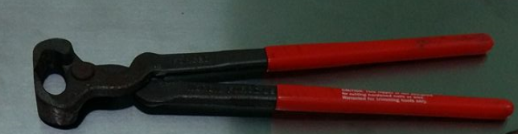
Hoof clippers allow for trimming of the hooves in equine, bovine, caprine and ovine species to the proper length in order to prevent hoof rot. How to use: https://www.youtube.com/watch?v=ZGDDQAk6KGE

Hoof Pick
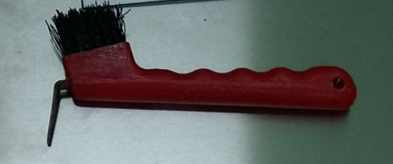
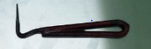
Used to remove stones, pebbles and dirt that may be stuck to the hoof. This prevents foreign bodies from being stuck to the hooves and causing discomfort which has the potential to cause infection. How to use: https://www.youtube.com/watch?v=wZ8lsOoT4O8
Hoof Knife Sharpener
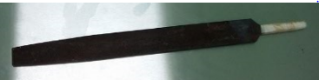
Used to file the hoof knives. How to use: https://www.youtube.com/watch?v=Vgkdx5vkssg

Hoof Knife
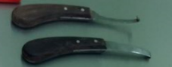
Used for detail on hoof trimming. How to use: https://www.youtube.com/watch?v=hZ--WT58Kak
Hoof Tester
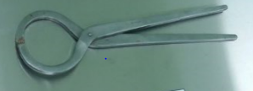
This is used to localize pain in an animal’s hoof without causing too much additional discomfort. How to use: https://www.youtube.com/watch?v=eK81NatuGlU

CASTRATION
Callicrate Bander
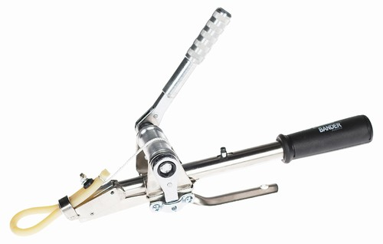
The Callicrate Bander is a bloodless, high tension method of non-surgical removal, including castration, dehorning and prolapse treatment. It ensures proper tensioned ligation (the key to effective, low stress, humane castration). It results in ischemic necrosis of the scrotum. How to use: https://www.youtube.com/watch?v=vthCZJEPIRA

Emasculator
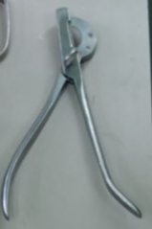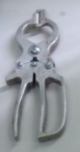
This is used for open castration. It has a crushing end and a cutting end. The crushing end is placed towards the animal. It simultaneously crushes and cuts the spermatic cord, preventing haemorrhaging while still detaching the testis from the animal. How to use: https://www.youtube.com/watch?v=EZv4q_BRJXI
Burdizzo
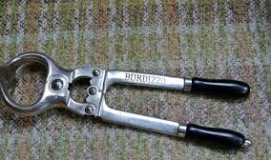
The Burdizzo is a castration device which employs a large clamp designed to break the blood vessels leading into the testicles. Once the blood supply to the testicles is lost, testicular necrosis occurs, and the testicles shrink, soften, and eventually deteriorate completely. When the device is used, the operator crushes the spermatic cords one at a time, leaving a space in between in order to maintain an interruption of blood-flow to the scrotum. How to use: https://www.youtube.com/watch?v=nLq0-Ns3Vls

DEHORNING
Rhinehart calf dehorner\ Disbudder
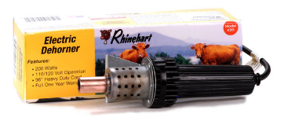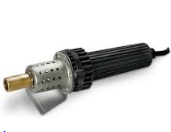
After applying an anaesthetic block, the heated part of the disbudder is placed on the horn head, destroying the germinal cells that the horn grows from. How to use: https://www.youtube.com/watch?v=jY5SnLc5uqU
Gigli Wire and handles
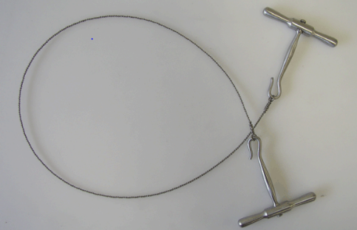
The wire is composed of multiple, flexible wires twisted in such a way so as to create multiple cutting surfaces. The wire is moved back and forth about 180 degrees about the horn. How to use: https://www.youtube.com/watch?v=GxV35EZ1px4

Dehorner (Barnes dehorner)
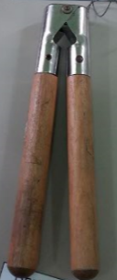
After an anaesthetic block is applied, place over the horn and twist. How to use: https://www.youtube.com/watch?v=y7W-YKmNADY
Restraint
Kow Kan’t Kick
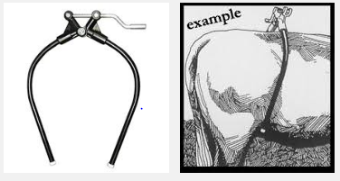
This is used via slipping it over the animal’s back and the handle is cranked to immobilize the muscles of the rear legs that control kicking. How to use: https://www.youtube.com/watch?v=dHFpxiXHF4U

Head Halter
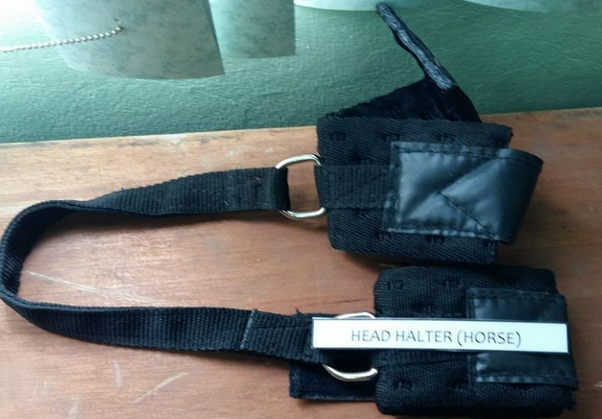
Used to restrain the head of the animal so other procedures can be performed. How to use: https://www.youtube.com/watch?v=zy-G8Lc60iI

Twitch
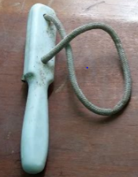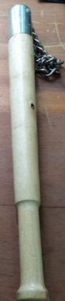
The twitch is placed around the upper lip of the animal, is twisted and pulled. How to use: https://www.youtube.com/watch?v=78yK3c4tNuM
Haussman’s Mouth Gag for horses
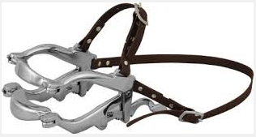
This is used to keep the mouth of the horse open for inspection of the oral cavity. How to use: https://www.youtube.com/watch?v=9ROKgr7Iqh0

Cattle mouth gag
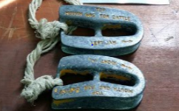
This is used to keep the mouth open for examination of the oral cavity. How to use: https://www.youtube.com/watch?v=o30nf8aM6yI
Nose ring
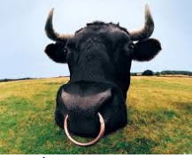
Used as a method of restraint to distract the bovine as well as keep its head in one place. It is applied via a nose punch.
Electric goad\ cattle prod
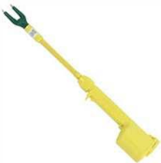
This uses an electric shock to move cattle (poor animal welfare).

Hog Snare
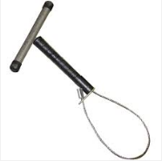
Twisted around the upper lip of the pig and is pulled for restraint. How to use: https://www.youtube.com/watch?v=FFYpJDjjmA4

CALVING
Calving chain and hooks
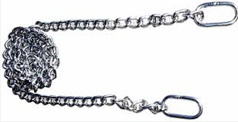
This is placed on the hind legs of the calf and is pulled for assistance with calving. How to use: https://www.youtube.com/watch?v=vJRDvhb8QUQ
Calf Puller and Jack
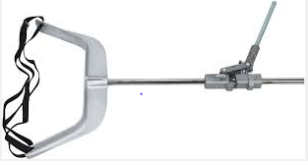
This is used for assistance with calving when there is dystocia. How to use: https://www.youtube.com/watch?v=_HyApxVijCU

Fetotome
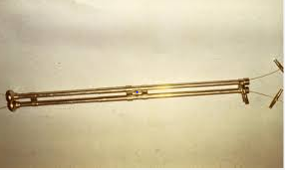
This is used only to rid a cow of a dead foetus that is unable to come out (fetotomy). How to use: https://www.youtube.com/watch?v=-ptkF0nIZJI

Save Ewe Prolapse Retainer
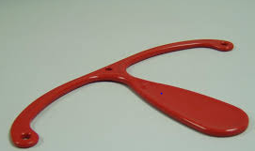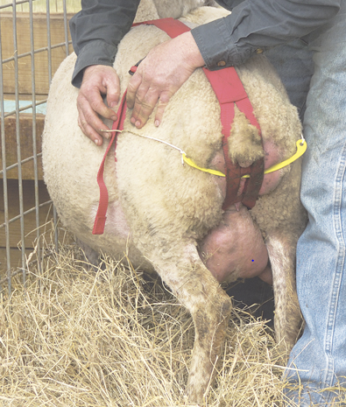
Using a prolapse retainer is the most gentle “cure” for a prolapse. If properly fitted it will prevent ewes from straining and pushing the prolapse back out.

