**Materials required**

**Minimum equipment**

* Basic [surgical](https://www.vetstream.com/canis/Content/Freeform/fre00618.asp) pack .
* Fig.1 Surgical instruments self-retaining retractors - Balfour abdominal

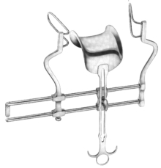Balfour retractors [*(Fig. 1)*](https://www.vetstream.com/canis/Content/Technique/teq00814#Fig--1).

* DeBakey forceps.
* Doyens intestinal forceps (if working alone).

**Ideal equipment**

* Suction.
* Assistant to hold intestines is preferable to Doyens forceps.
* Electrocautery.
* Gastro-intestinal anastomosis (GIA) stapler and staples.

**Minimum consumables**

* 3-0 to 4-0 monofilament suture with a swaged on tapered or taper-cut needle.
* Scalpel blade.
* Gauze sponges.
* Warmed saline to flush abdomen after enterectomy closure.
* Suture to close abdomen - size dependant on size of patient.

**Ideal consumables**

* 3-0 to 4-0 monofilament absorbable suture with a swaged on tapered or taper-cut needle - Polydioxanone (PDS), Polyglyconate (Maxon) suture material.
* Skin staples.
* Laparotomy pads/sponges.
* Radiopaque gauze sponges.