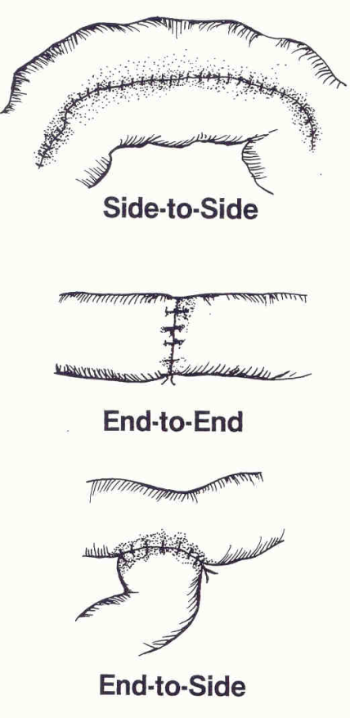
Types of anastomosis

Type is based on:
- surgeon preference,
- condition being treated and
- location of lesion
NOTE: For intersusseption - The margins for excision are selected in healthy-appearing intestine. In general, the distal margin may be 10 cm aborad to the lesion, but the proximal margin should be a minimum of 30 cm orad to the lesion. The larger proximal segment is chosen because chronic distention, inflammation, microvascular thrombosis, relative ischemia, and noxious ingesta accumulated in this segment may cause severe and prolonged postoperative ileus.

