Resection & Anastomosis: Enteretomy technique
Procedure:
- Enter abdomen via a midline incision.
- Identify and exteriorize the affected segment of bowel, along with 15 to 20 cm of normal bowel orad and aborad to the segment to be resected.
- Use several layers of moist laparotomy sponges to isolate (“pack off ”) this bowel from the rest of the abdomen.
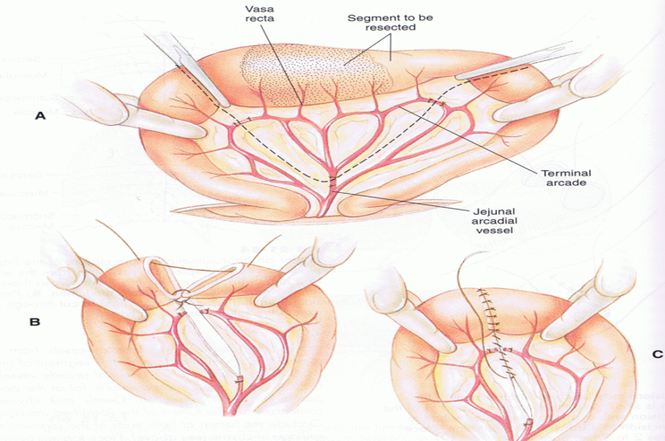
- Isolate and ligate the mesenteric vessels to the affected area.

- The mesenteric vessels (arteries and veins) are ligated using ‘‘mass ligation’’ with absorbable suture material (#3 chromic gut, #1 polyglactin 910) being sure not to compromise the blood supply to the intestine to be preserved.

  - Mass ligation is required because cattle do not have an arcuate vascular anatomy as do horses and the fatty mesentery render vessels identification impossible.
  - The sutures are placed in an overlapping pattern such that double ligation of the vessels is accomplished

- Place crusing clamp across the bowel at a 60 degree angle to the long axis of the bowel.
- Milk the ingestia away from the crusing clamp and place a non-crushing clamp across the viable segment of the bowel to be anastomosed or have an assistant hold the bowel segments.
- Excise the diseased bowel by between the crusing clamp (make sure to include the tissue crushed by the clamp) and the arcadia vessel ligation.
  - In general, the distal margin may be 10 cm aborad to the lesion, but the proximal margin should be a minimum of 30 cm orad to the lesion.

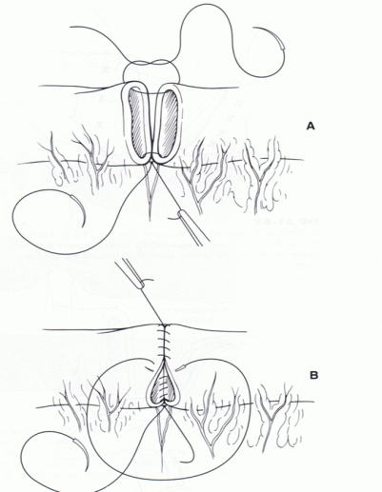
- Suture by 3/0 or 4/0, all knots are extra luminal (an excetion is made for the first sutre to allow for accurate joining of the mesenteric sides, the most important suture)
  - Carefully place the first suture at the mesenteric border
  - The second suture apposes the antimesentric border
  - Place sutures approximately 2-3mm apart along the “near” side of the anastomosis.
  - Include the entire thickness of the bowel
  - Appose the “far” side similarly

- Rinse the enterectomy site thoroughly with warm saline
- Check for leakage by injecting sterile saline near the suture line and applying some force, leakage indicates an insufficiently closed suture line and can be corrected with a few simple interrupted sutures.

- Use of omentum to reinforce the suture line (even in relatively healthy tissue) by wraping a piece of the omentum around the line of anastomosis and gently tacking it to the bowel above and below the anastomosis
- Close the defect in the mesentry with a continuous suture as seen in the first picture,c.
- Perform routine abdominal closure.

