Disarticulation:

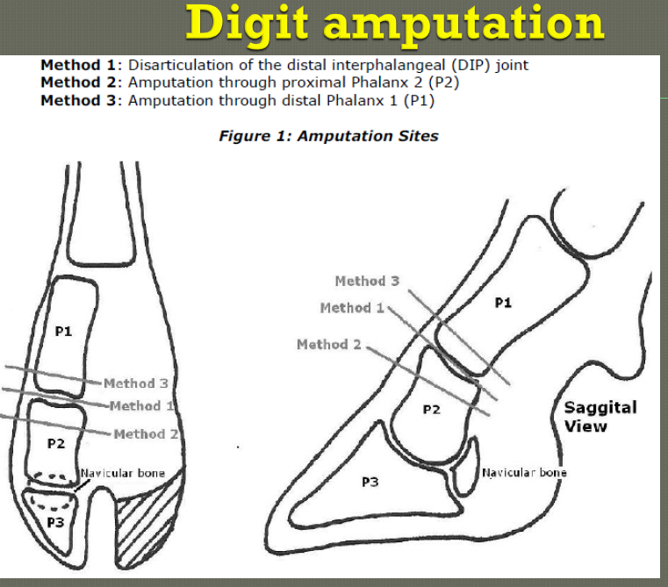

Amputation of one digit at the proximal interphalangeal joint or just above is a common procedure in cattle practice.

Procedure:

1. After preparation a skin incision is made in the interdigital space and then beginning about 2 cm proximal to the interdigital cleft angling upward to a point on the lateral or medial side of the leg even with the distal margin of the accessory digit or dewclaw.
2. All soft tissues can be sharply incised along the line of the skin incision.
3. The digit may be amputated by sharp dissection to disarticulate the proximal or the distal interphalangeal joints. The blade cuts the connecting tissue between the bones and removes the tissue. There can be two types of disarticulation:

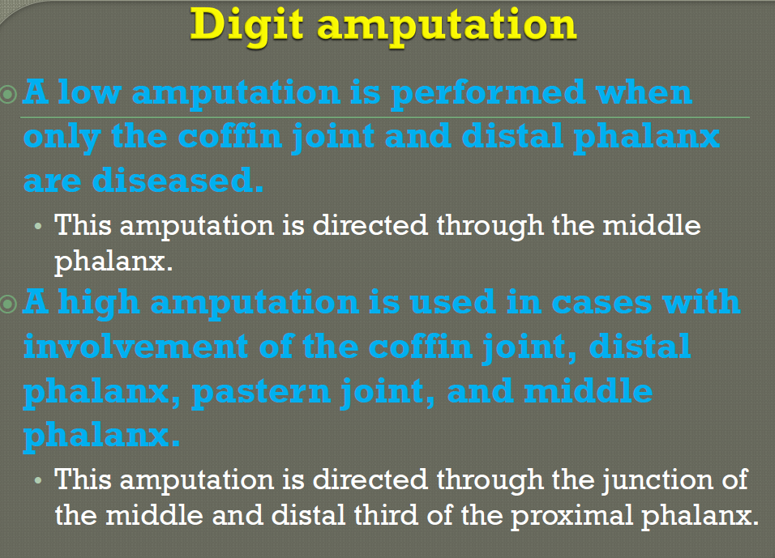

1. Some practitioners ligate one or two arteries and others simply use a very tight bandage.
2. The cut surface of the removed portion should be carefully examined for evidence of sepsis or necrosis. If damaged tissue extends above the amputation and it is not debrided the outcome will be poor. After determining that all diseased tissue is removed, the surface of the wound is covered with an antiseptic or antibiotic dressing and a bandage applied to control hemorrhage.