Drug Table:
This lab session would require sedation as well as anaesthesia so the following drugs would be recommended.
Sedative:
Class of drug | Name of drug | Active ingredient | Description | Indications | Adverse effects | Dosage
Sedative | Bomazine  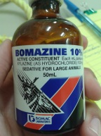 | Xylaxine(as Hydrochloride) | Alpha 2 adrenergic agonist | Emetic in cats  Sedative and analgesia in many species  Pre anesthetic | Horses:  Emesis, muscle reaction, tremors, bradycardia with partial A-V block, reduced respiratory rate, movement in sharp stimulation, sweating, increased intracranial pressure, decreased mucociliary clearance  Cattle:  Salivation, ruminal atony, bloating, regurgitation ,hypothermia , diarrhea, bradycardia , premature parturition, ataxia | Dogs and cats:  1.1mg/kg IV  Cattle :  Protocol requires use of Butorphanol /Xylazine/Ketamin  0.01-0.025 mg/kg Butorphanol  0.02-0.05 mg/kg Xylazine  0.04-0.1 mg/kg Ketamin

Anaesthetic:
Intravenous Regional Anaesthesia (IVRA)
Lidocaine 2% | 20mg/ml | 2.5mls | Amount given: 2.5ml diluted to 5ml with saline | Milk: 24 hours  Meat: 1 day | Local anaesthetic
Non  Steroidal  Anti Inflammatory Drug  (NSAID) | Banamine  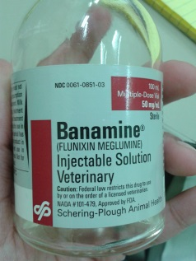 | Flunixin meglumine | Used to relieve pain, fever and inflammation by inhibiting COX 1 and COX 2. | Alleviation of pain and inflammation associated with musculoskeletal disorders of horses  Alleviation of visceral pain associated with equine colic  Control of pyrexia in bovine respiratory disease and endotoxemia  Control Pyrexia associated with swine respiratory disease | Can exacerbate existing ulcers  Hypersensitivity reactions  Potential delay in parturition  GI and Renal toxicity

