Step 1. Trim toe 'length' to 7.5 cm (more or less in some cows)
For hind feet, trim the inner claw (most normal)
For front feet, trim the outer claw (most normal)

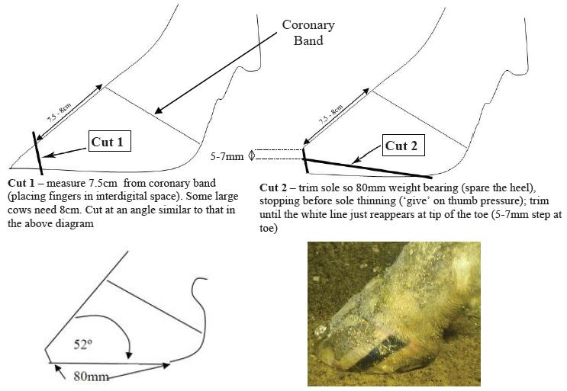

Reference;
1. Nadisorguk. 1. Nadisorguk. [Online]. Available from: http://www.nadis.org.uk/bulletins/lameness-control-in-dairy-herds/part-1-practical-foot-trimming-(dutch-5-step-method).aspx [Accessed 11 October 2015].
In-text citation: (1)

