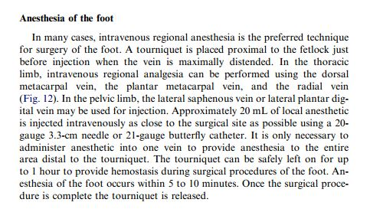

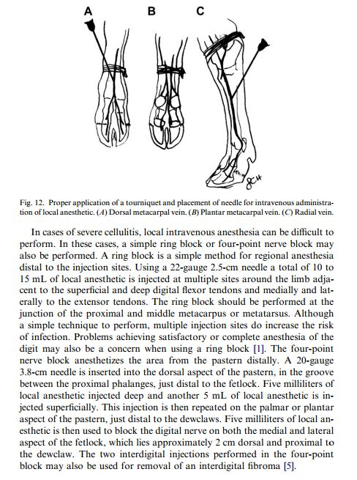

Reference:

Local and Regional Anesthesia in Cattle, Misty A. Edmondson, DVM, MS

Department of Clinical Sciences, Auburn University College of Veterinary Medicine,

1500 Wire Road, Auburn, AL 36849, USA