Scoop, Gouge or Barnes-Type Dehorner
Scoop dehorners are used for calves ranging in age from two to four months with horns up to four inches long (Figure 6). Some operators claim better dehorning with a rectangular-shaped scoop because it removes an even ring of skin around and with the horn bud. When used properly, it does not go too deep, but the dehorner can open the frontal sinus when used at the top end of the age and horn-size range. The blades must be kept sharp for best results.
Technique
- Administer sedation, analgesia and local anaesthetic.
- Close the handles together.
- Place the jaws of the dehorner over the horn bud. The objective is to completely remove a ring of skin surrounding the horn base. Therefore, adjust the opening as needed (Figure 7).
- Press the gouger gently against the head. Maintain the pressure and quickly spread the handles apart to bring the blades together to remove skin and the horn bud.
- Control bleeding by pulling the artery with forceps or using a hot iron to cauterize the artery.
- Clean and disinfect the jaws of the gouger between calves.
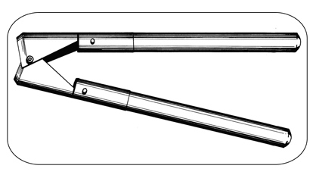
Figure 6. A Barnes-type dehorner scoops the horn and horn-producing skin surrounding the horn base.

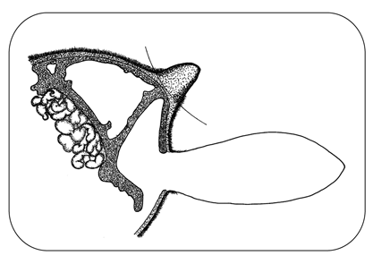
Figure 7. With young calves, the Barnes-type dehorner removes horn-producing skin but does not cut into the frontal sinus as shown by the arced line in Figure 7. In older calves with the horn attached to the skull, the dehorner cuts into the frontal sinus.
Advantages and Disadvantages
- fast - takes a few seconds to perform
- useful after the horn bud attaches to the skull
- not bloodless
- risk of infection because of open wounds
- opens the frontal sinus in older calves
- avoid use during fly season
- unreliable when done incorrectly, leads to scurs
- requires expertise - anaesthesia, sedation, analgesia and technique
- requires control of bleeding - pulling arteries or cautery
Reference;
1. Thebeefsitecom. 1. The Beef Site. [Online]. Available from: http://www.thebeefsite.com/articles/2261/dehorning-of-calves/ [Accessed 26 September 2015]. In-text citation: (1)

