Chemical Dehorning
Caustic chemicals will prevent the growth of horns when properly applied to the horn buds of new-born (less than one to three weeks of age) calves. The chemical destroys the horn-producing cells around the horn bud. The chemicals are available as sticks or pastes (Figure 2). To protect yourself, wear gloves when applying the chemicals. To protect the calf, avoid application near its eyes. Do not use caustics in rainy weather.
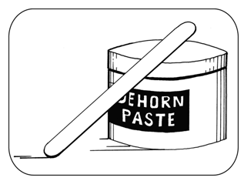
Figure 2. Dehorning paste is a caustic chemical applied to horn buds to destroy horn-producing cells.
Technique
- Administer sedation, analgesia and local anaesthetic.
- Expose the horn bud (about the size of a 5-cent piece) by pushing the hair back (Figure 3).
- Apply the caustic to the horn button. Use a wooden applicator. Apply a thin layer.
- Re-position the hair over the paste and horn bud - i.e., cover the horn bud.
- Although the package insert may instruct operators to clip hair at the horn bud, experienced operators have shown that not clipping hair is preferable, because the hair keeps the caustic in place, reduces the risk of irritation to the cows udder and flanks and reduces irritation to other facial skin of the calf.
- Protect the calf and the cow from accidental caustic burns. One method is to place a patch of duct tape over each horn bud. The duct tape usually falls off in a few days. For dairy calves, keep in individual pens.
- In some countries, the technique is only permitted in calves less than eight days of age.
Advantages and Disadvantages
- performed at a young age with less stress than some other techniques
- bloodless
- use in any season
- painful without anaesthesia
- avoid contact with eyes; operator should wear gloves
- do not use in rainy weather
- not permitted in some countries
- horns or scurs follow improper technique
- requires pain control
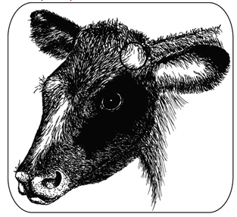
Figure 3. The circle at the base of the ear shows the location of the horn bud in a young calf. The horn bud is readily visible after pushing back the hair. Reposition the hair over the paste and bud after applying the dehorning paste.

Reference;
1. Thebeefsitecom. 1. The Beef Site. [Online]. Available from: http://www.thebeefsite.com/articles/2261/dehorning-of-calves/ [Accessed 26 September 2015].
In-text citation: (1)

