**GIGLI WIRE DEHORNING**

A Gigli saw is a flexible wire saw used by surgeons for bone cutting. A Gigli saw is used mainly for amputation, where the bones have to be smoothly cut at the level of amputation. Alternatively the gigli wire was used in our lab as a mechanical method of dehorning.

Technique

1. The head of the animal was positioned in a ventral direction i.e. towards the ground.
2. The gigli wire was place around the horn and surrounding tissue (approximately ½ inch of skin.)
3. In our lab the primary cut was difficult to make so an incision was made about ½ above the horn which was used as our starting point for the gigli wire.
4. The wire was then smoothly but quickly moved back and fort until the horn and surrounding tissue was removed, making sure that the pulling movement was made while holding the more ventrally towards the ground to ensure that a portion of the skin would be removed with the horn.
5. The bleeding blood vessels were then clamped with a haemostat and twisted to stop bleeding.
6. If step 5 failed the hot iron was used to cauterize the blood vessels.

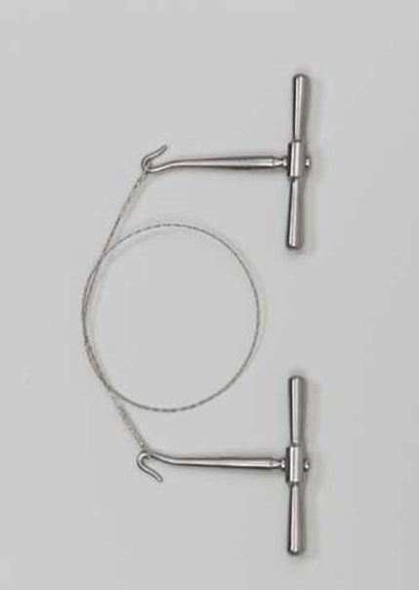

*Image showing the gigli wire or gigli saw.*

ADVANTAGES AND DISADVANTAGES

* It can be used for older cattle with larger horns.
* It creates heat while sawing which in some cases cauterizes the area while removing the horn.
* useful after the horn bud attaches to the skull
* not bloodless
* risk of infection because of open wounds
* opens the frontal sinus in older calves
* avoid use during fly season
* requires expertise - anaesthesia, sedation, analgesia and technique
* requires control of bleeding - pulling arteries or cautery