**KEYSTONE OR “GUILLOTINE” DEHORNING**

A keystone dehorner has two handles that move a blade downward against a plate or another blade, slicing through the base of the horn and surrounding skin. It is primarily used for older calves due to its ease of cutting and also due to the larger size of the horns in older cattle.

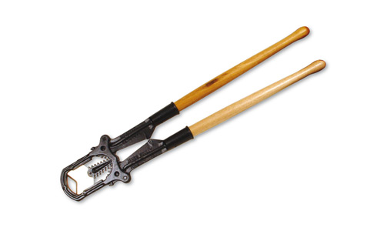

*Figure showing the Keystone or Guillotine dehorner.*

Technique

1. Place open blade over the horn base.
2. Allow for removal of ½ inch ring of skin surrounding the base of the horn.
3. Quickly close the handles, thus clipping off the horns.
4. This cut destroys cells from which the horn grows.

Advantages and Disadvantages

* can be used in older cattle with large horns.
* greater risk of exposed sinus, infection and blood loss; painful; may lead to set-backs in overall health and performance, including weight loss; requires follow-up care; poses risk of injury to the animal and handler.
* not bloodless
* open sinus can lead to infection
* requires expertise - anaesthesia, sedation, analgesia and technique
* requires control of bleeding - pulling arteries or cautery
* avoid use during fly season
* opens the frontal sinus in older calves
* risk of infection because of open wounds