**DEHORNING SPOON OR TUBE**

Dehorning spoons or tubes provide a quick and efficient technique for removing horn buds in calves less than eight weeks of age. With this method, a sharpened metal tube cuts through and removes the horn-producing skin at the base of the horn bud. Use the proper size tube to remove the horn plus about 1/8 inch of skin around the entire horn bud.

Technique

1. Administer sedation, analgesia and local anaesthetic.
2. Select the correct size tube (4 sizes available) to fit over the horn bud, and cover about 1/8 inch of skin around the horn base.
3. Place the cutting edge straight down over the horn.
4. Apply pressure to the tube; push and twist the tube until the skin has been cut through.
5. Cut under the horn bud and remove it, using a scooping motion.
6. Apply an antiseptic to the wound. Some bleeding may occur.
7. Clean and disinfect the cutting edge of the tube between calves.

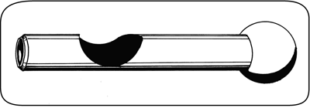

*A dehorning spoon or tube is used to remove the horn bud plus the horn-producing skin at the base of the bud.*

Advantages and Disadvantages

* not bloodless
* useful for young calves
* risk of infection because of open wounds
* avoid use during fly season
* unreliable when done incorrectly, leads to scurs
* requires expertise - pain control, technique, control of bleeding