**ADVANTAGES**

* performed at a young age with less stress than some other techniques
* bloodless
* use in any season

**DISADVANTAGES**

* painful without anaesthesia
* avoid contact with eyes; operator should wear gloves
* do not use in rainy weather
* not permitted in some countries
* horns or scurs follow improper technique
* requires pain control

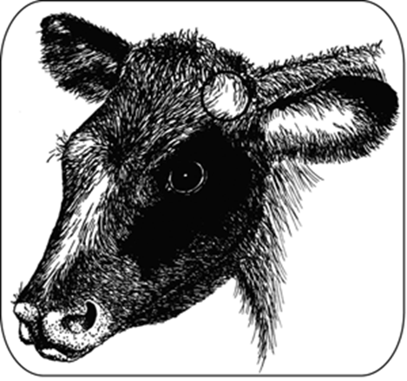

*The circle at the base of the ear shows the location of the horn bud in a young calf. The horn bud is readily visible after pushing back the hair. Reposition the hair over the paste and bud after applying the dehorning paste.*