**Castration of Bovine**

Castration (Gonadectomy) is the surgical removal of the gonads (gametes producing cells) in the male (testicles and epididymis) and the female (ovaries (Spay/ovariohysterectomy)). This alters the normal function of the organs by preventing the production of male hormone and as a result the animal is unable to reproduce. “The castration of calves in early life (before4 months of age) is less stressful to calves than in later stage when testicles are developed. In addition, early castration raises less concern about humane treatment.” Also during early castration the animal is easy to handle as compared to older animals (which also tends to have a setback, costing the owner money.

Castrated calve is known as a steer. A steer tends to be a lot more docile as compare to an intact male (bull). Beef marketing system favours steer carcasses because of finer texture of lean and more marbling of meat. They also finish earlier (fatten quicker) than bulls because of fat deposition occurs at a faster rate. On the other hand steers can be mixed with females (and new individual to feedlot) in pasture or in lots without causing any management problems, and also eliminates possibility of using inferior bulls.

**Method of castration in cattle**

Closed castration method **(Burdizzo clamp)**

The closed technique is normally used in young calves when the spermatic cord and vessels can be felt. With this technique the peritoneal cavity (vaginal tunic) is never open. This method is done with a Burdizzo clamp. It is important to locate each spermatic cord and pull them to the side. Ensure that the spermatic cord is between the Burdizzo clamp before squeezing the clamp. Keep clamp closed for no less than 2 minutes to ensure proper crushing of the cord. While the clamp is crushing always ensure that the cord is being crushed because it is likely to slip from between the clamp when squeezed. Pulling the spermatic cord to the side will prevent the crushing of blood supply to the scrotum. The logic behind the use of the Burdizzo is to form a thrombus in the spermatic vessel that would arrest the blood supple which in turn would lead to atrophy of the testes. Restriction of blood supply to the scrotal sac will result in gangrene and falls off. As a result of this, it is important that we crush both cords at different levels of the scrotal sac to ensure proper blood supply to the scrotum after the procedure.

**Points to note**

* Failure to crush spermatic cord will result in animal carrying out normal intact male behaviour.
* Check for shrinkage/atrophy (smaller) of scrotal sac in about 2 weeks
* Notice symmetry of testicular shrinkage/atrophy (should be even if both spermatic cords were crushed.
* Bloodless, less chance of infection (no open wound)
* No risk of maggot infestation.
* Less painful, quick and easy.

Closed castration **(Rubber rings/Elastrator)**

* Rings are placed around scrotal sac at about 10 days. Older animals will undergo a lot more pain which is stressful to the animal which in turn could decrease growth. Animal could also get a general infection.
* Check if both animals are descended before placing the rings. If one testis remains (Cryptorchism) in the abdominal cavity the animal will mostly like carry out normal intact bull behaviour (not likely to reproduce but produce the hormone).
* Calves are easily handles, with little labour.
* This technique is bloodless.
* Routine checks to ensure that ring doesn’t break which would result in animal not being castrated.

Open Castration method

There are two types of open castration method. In both techniques/method each testis is pulled through an incision made in the scrotal sac. This method is done using a sharp knife, or an emasculator.

* Open Uncovered “Open-Open” Method

In this technique/method the vaginal tunic is opened, in which the peritoneal cavity is exposed. The use of the emasculator (nut-nut) crushes the ductus deferens, cremaster muscle, the spermatic vessels, and the parietal tunic.

* Open Covered “Open-Close” method

In this technique/method the vaginal tunic is not opened, the peritoneal cavity is not exposed neither are the testes. A haemostat is placed proximally to the testes followed by a knot to ensure no bleeding after ligation. The emasculator is not used in this method because of fear that it will the testicular artery of the crushed tissue. This procedure should be done in a sterile environment.

**Points to notes**

* Ensure the use of antibiotic is used along with sprays against flies
* Wash hands before attempting to make any incision
* Ensure no bleeding after surgery
* Enlarge incisions to prevent “pockets” from forming to allow proper drainage
* Horizontal incisions vs vertical incisions

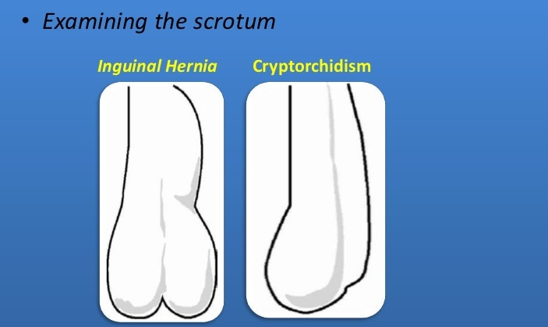

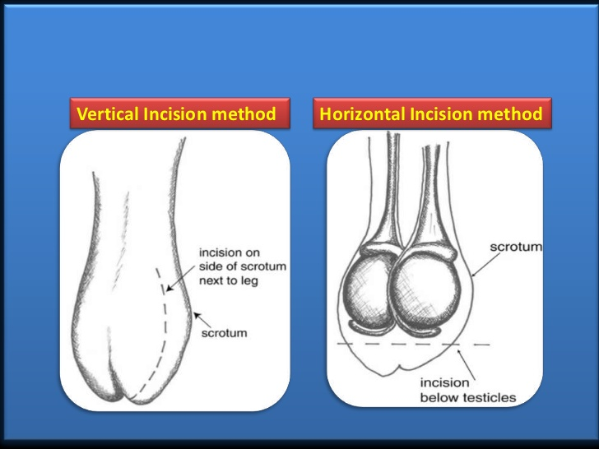

Crush sites for the Burdizzo clamp

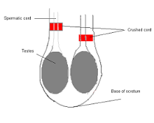

**References**

(Including knowledge)

* Pasquini, Spurgeon, Pasquini., Anatomy of Domestic animals, 11 edition, page 360
* [http://www.slideshare.net/vetkkarthik/castration-in-large-animalsppt 21.9.15](http://www.slideshare.net/vetkkarthik/castration-in-large-animalsppt%2021.9.15)