Pre-operative drugs used
Name of drug | Class of drug |  | Active ingredient | Description | Indications | Adverse effects | Dosage given | Other info
Ketamine 10% | Anesthetic  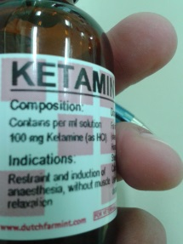 |  | Ketamin. | Dissociative general anesthetic that inhibits NMDA receptors thereby allowing control of pain | Anesthetic  Analgesic | Hypersensitivity reaction  Pain after injection IM  Respiratory depression  Emesis  Vocalization  Erratic and prolonged recovery  Dyspnea  Spastic jerking motions  Cardiac arrest | Dosage rates differ with the combination of drugs it is combined with:  Cattle: | Contraindications:  Known hypersensitivity reactions, animals used for human consumption, as sole general anesthetic, increases CSF pressure, head trauma  Drug interactions:  CNS depressants- increase recovery time  Halothane -recovery rates increased  Neuromuscular blockage- enhanced respiratory depression  Caution using in: hypertensive , arterial aneurisms, heart failure  Atropine can be used to control hypersalivation and other autonomic sigs  Cats eyes remain open after administration so application of lubricant drops are need  Spasmolytic agents can be used to treat the convulsive side effects (e.g, acepromazine)

