**Burdizzo Clamps for Castration**

The Burdizzo method crushes the blood vessels, interrupts the blood supply to the testicle and thus kills the testicle. Good restraint is essential because the Burdizzo must be in place about 10 seconds to crush the artery.

The Burdizzo (Figure 3) must be in good condition. The jaws must be parallel and close uniformly across their width so pressure will be evenly distributed across their length. Leave the Burdizzo slightly open when not in use.

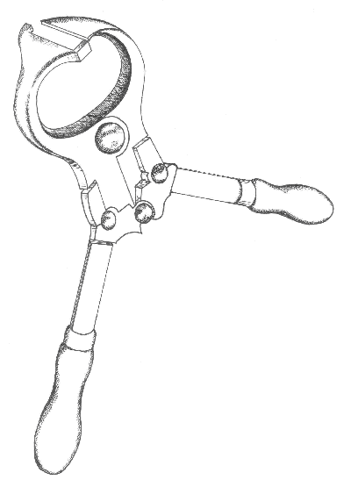

**Figure 3**. Burdizzo clamp.

**Technique**

1. Use this technique when the spermatic cord can be palpated - one month and older.
2. Choose and use the proper sized forceps for the size of animal. With undersized forceps, there will be too much tissue between the jaws and there will not be enough force to properly crush the arteries.
3. Find the spermatic cord on one side of the scrotum. Reach between the hind legs and grasp the scrotum above the testicles. The spermatic cord runs from the testicle into the calf's body. It is about the size of a pencil and moves easily from side to side in its half of the scrotum. Pinch the cord to the outside edge of the scrotum between your thumb and forefinger. If right handed, use your left hand to hold the cord and your right to operate the Burdizzo.
4. Position the Burdizzo correctly for crushing. One jaw of the Burdizzo has projections at each end to keep the spermatic cord from slipping out of the Burdizzo. Place the jaw with the projections on the front side of the scrotum. Point the projections toward you.
5. Include only the part of the scrotum that contains the spermatic cord between the jaws of the Burdizzo. Do not crush more of the scrotum than necessary. The jaws should be placed just above (1-1.5 cm) the top of the testicle.
6. Close the Burdizzo, count out 10 seconds and check to be sure the spermatic cord has been held between the jaws of the Burdizzo. You can also rock the spermatic cord back and forth in the jaws.
7. Release the Burdizzo, move it to a new site 1 cm below your first site, and repeat steps four and five. Choose a site below the first crush to minimize acute pain from a second crush.
8. Repeat the procedure on the opposite side. Stagger the pinched areas on the left and right side of the scrotum. Do not pinch a part of the scrotum that lines up with a pinch on the opposite side. The crush lines must not overlap the centre-line of the scrotum (Figure 4).
9. Check calves four to six weeks later to be sure the testicles have shriveled. The testicles swell initially and then degenerate and shrink in size.

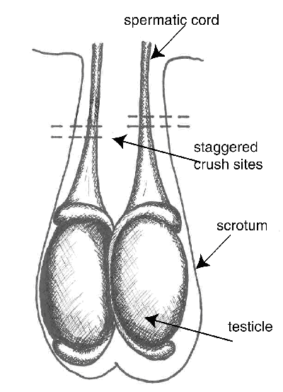

**Figure 4**. Burdizzo castration sites.

Pain:

* local anaesthesia plus a non-steroidal anti-inflammatory drug are needed to eliminate acute pain caused by Burdizzo castration
* acute pain caused by Burdizzo clamps is less than that caused by surgical, rubber-ring or latex-band castration

Advantages and Disadvantages:

* bloodless
* slow to perform and requires expertise
* unreliable when done incorrectly, leads to stags
* equipment becomes ineffective after long-term use and must be replaced
* less reduction in weight gain after castration compared to surgical or latex-band