Mesopotamia

Artifact Box Handout

EDTL 6430

Michelle Huffman (Kiracofe)

**Social Studies:**

**Theme**: Regions and People of the Eastern Hemisphere

**History Strand**

**Early Civilizations** - The eight features of civilizations include cities, well-organized central governments, complex religions, job specialization, social classes, arts and architecture, public works and writing. Early peoples developed unique civilizations. Several civilizations established empires with legacies influencing later peoples.

**Content Statement: 2**. Early civilizations (India, Egypt, China and Mesopotamia) with unique governments, economic systems, social structures, religions, technologies and agricultural practices and products flourished as a result of favorable geographic characteristics. The cultural practices and products of these early civilizations can be used to help understand the Eastern Hemisphere today.

**Geography Strand**

**Human Systems**: Human systems represent the settlement and structures created by people on Earth’s surface. The growth, distribution and movements of people are driving forces behind human and physical events. Geographers study patterns in cultures and the changes that result from human processes, migrations and the diffusion of new cultural traits.

**Content Statement: 6**. Variations among physical environments within the Eastern Hemisphere influence human activities. Human activities also alter the physical environment.

**Literacy**

**[CCSS.ELA-LITERACY.W.6.2](http://www.corestandards.org/ELA-Literacy/W/6/2/)**  
Write informative/explanatory texts to examine a topic and convey ideas, concepts, and information through the selection, organization, and analysis of relevant content.

**[CCSS.ELA-LITERACY.W.6.2.A](http://www.corestandards.org/ELA-Literacy/W/6/2/a/)**  
Introduce a topic; organize ideas, concepts, and information, using strategies such as definition, classification, comparison/contrast, and cause/effect; include formatting (e.g., headings), graphics (e.g., charts, tables), and multimedia when useful to aiding comprehension.

**[CCSS.ELA-LITERACY.W.6.2.B](http://www.corestandards.org/ELA-Literacy/W/6/2/b/)**  
Develop the topic with relevant facts, definitions, concrete details, quotations, or other information and examples.

**[CCSS.ELA-LITERACY.W.6.2.D](http://www.corestandards.org/ELA-Literacy/W/6/2/d/)**  
Use precise language and domain-specific vocabulary to inform about or explain the topic.

**Introductory Information**

Mesopotamia means “the land between rivers” and refers to the Middle East area between the Tigris and Euphrates Rivers and the surrounding area. The modern countries in this area are Iraq, Iran, Syria, and Turkey. Many speculate that the key to successful cultures in this area was the presence geographical features, specifically abundant water from the rivers for irrigation and agriculture.

Mesopotamia was home to the first human civilization and is known as the “cradle of civilization.” Work was able to be specialized, since people were no longer dedicated all of their time to nomadic searches for food. Mesopotamia is credited with significant inventions including the wheel and cuneiform writing.

Major civilizations existing in Mesopotamia over time included the Sumerians, Akkadians, Babylonians, Assyrians, and Persians.

**In the Box**

**Civilization-in-a-Bag**

Everything you need to make a city! Two rivers, fertile soil, and people. 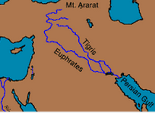 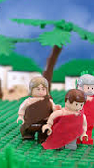

Mesopotamia is significant for being home to the first civilization. Prior to the formation of civilization, people were nomads. Humans existed in small groups traveling in search of food. The rich soil between the Tigris and Euphrates Rivers and natural resources in Mesopotamia allowed for the formation of cities through the development of agriculture. People could settle in one place and no longer needed to pursue a nomadic life. As more nomadic groups joined the agricultural settlement as a permanent residence, every individual did not need to be engaged in the pursuit of food. As such, specialization of labor occurred. Goods were produced at an excess and an economy of trade developed.

Students will collaborate to decide what elements are necessary for making a city. They will choose from representative materials (water, land, humans, crops, natural resources, gold). Designated reporters will share out to the class. Students will complete a Gallery Walk and offer feedback to peer groups on Post-It notes.

**Wheel**

The Sumerians in Mesopotamia are credited with inventing the wheel. It was not used for transportation purposes until later. The original wheel was likely a potter’s wheel. This tool allowed for more efficient and higher-quality production of clay vessels.

How has this invention influenced life today? Take 2 minutes and visualize life without the wheel.

The “wheel” I am including in my artifact box is merely a paper plate. I wanted to convey the commonplace nature of the wheel in today’s society such that students could see the contrast of life without this invention.

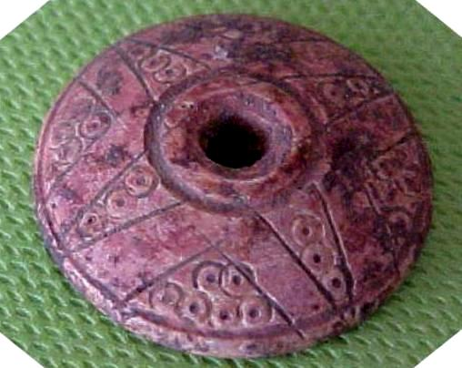

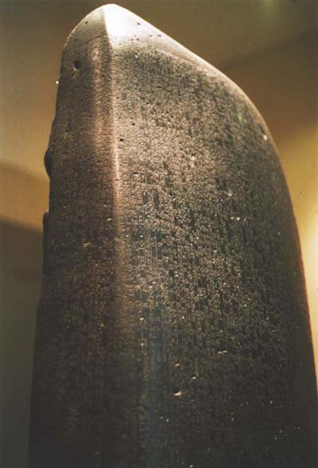**Rules**

The Babylonian law, the Code of Hammurabi, is believed to be the oldest written law in the world. King Hammurabi issued these 282 laws to govern behavior and set consequences for failure to comply. They are well-known for their harsh nature. Many are familiar with the retribution aspect of the laws such as, “an eye for an eye.” The Code of Hammurabi is inscribed on a 2.5 meter tall stele made of basalt.

Students will compare images of the Code of Hammurabi monument and the Student Code of Conduct that I have included in the Artifact Box. Students will complete a graphic organizer comparing the physical features and purpose of both documents.

Students will make a seven-foot tall stele to display the school rules.

**Cuneiform**

Cuneiform is an ancient form of writing. It was used to keep track of business exchanges (e.g., sale or trade of wheat and goats) as the economy revolved around trade.

Students will be given Play-Doh and a copy of the Sumerian “alphabet.” They will respond to an Exit Slip (very short response) on their “clay” in Sumerian code cuneiform. 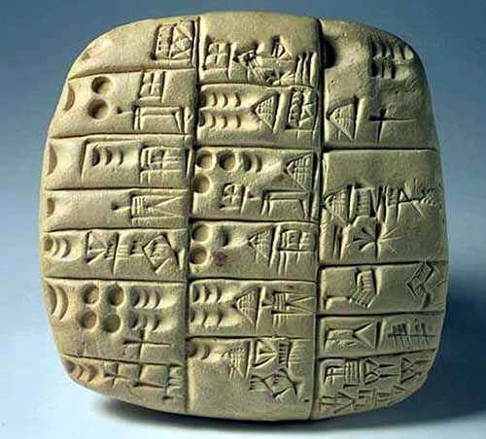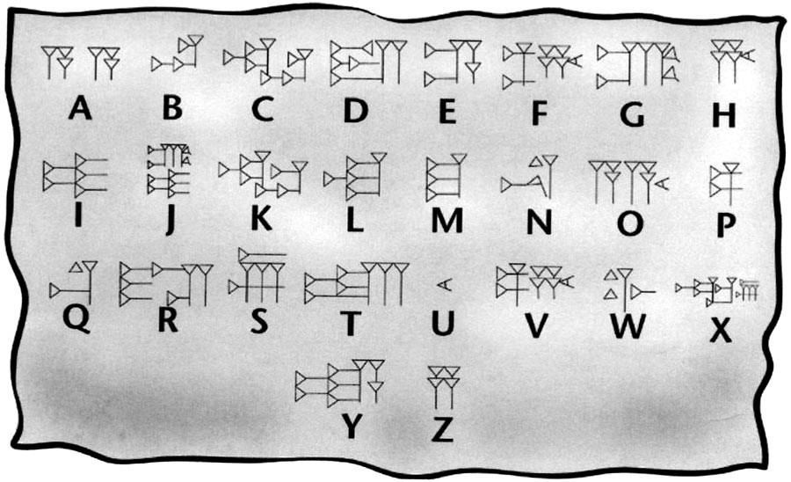

**Ziggurat**

Each major Mesopotamian city had a step pyramid called a ziggurat at its center. The structure was built to honor whichever god was the primary god of that particular city. For example, Murdock was the primary god of Babylon. Atop the ziggurat pyramid was a shrine for sacrifices and rituals. Civilizations in Mesopotamia were polytheistic; they had numerous gods. The people tried to keep the gods happy. If a natural disaster or other negative event happened, the people would attribute it to the displeasure of a particular god. Important deities included:

Shamash – god of the sun and justice

Ishtar – a female deity, goddess of love, fertility, and war

Ea – god of fresh water

Anu – sky god and father of the gods

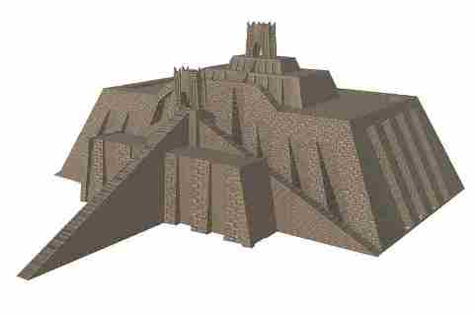

**Resources**

Andrews, E. (2013). *Eight things you may not know about Hammurabi’s Code*. Retrieved July 9, 2015, from <http://www.history.com/news/history-lists/8-things-you-may-not-know-about-hammurabis-code>

Lassieur, A. (2012). *Ancient Mesopotamia.* New York, NY: Scholastic Library Publishing.

Mark, J. (2009). *Ancient History Encyclopedia*. Retrieved July 9, 2015, from http://www.ancient.eu /Fertile_Crescent/

Nelson, K. (2015). *History for kids: Ancient Mesopotamia.*  Retrieved July 8, 2015, from <http://www.ducksters.com/history/mesopotamia/ancient_mesopotamia.php>

Nelson, K. (2015). *Ancient Mesopotamia: The ziggurat.* Retrieved July 10, 2015, from <http://www.ducksters.com/history/mesopotamia/ziggurats.php>

Steele, P. & Farndon, J. (2007). *DK eyewitness books: Mesopotamia*. New York, NY: DK Children.