|  |
| --- |
| http://www.epdlp.com/fotos/jahn09.jpg[**41-One Liberty Place**](javascript:void%20window.open('edificio.php?id=383','_blank','width=800,height=540,toolbar=no,scrollbars=yes,resizable=1');) *288 metros  Philadelphia (Pennsylvania) EEUU, América Arq. Helmut Jahn*  [*[http://www.epdlp.com/fotos/zoom.jpg](javascript:void%20window.open('edificio.php?id=383','_blank','width=800,height=540,toolbar=no,scrollbars=yes,resizable=1');)*](javascript:void%20window.open('edificio.php?id=383','_blank','width=800,height=540,toolbar=no,scrollbars=yes,resizable=1');) |

|  |
| --- |
| [*[http://www.epdlp.com/fotos/zoom.jpg](javascript:void%20window.open('edificio.php?id=1142','_blank','width=800,height=540,toolbar=no,scrollbars=yes,resizable=1');)*](javascript:void%20window.open('edificio.php?id=1142','_blank','width=800,height=540,toolbar=no,scrollbars=yes,resizable=1');) |

|  |
| --- |
|  |

|  |
| --- |
| [*[http://www.epdlp.com/fotos/zoom.jpg](javascript:void%20window.open('edificio.php?id=1126','_blank','width=800,height=540,toolbar=no,scrollbars=yes,resizable=1');)*](javascript:void%20window.open('edificio.php?id=1126','_blank','width=800,height=540,toolbar=no,scrollbars=yes,resizable=1');) |

|  |
| --- |
| http://www.epdlp.com/fotos/tange010.jpg[**45-Overseas Union Bank**](javascript:void%20window.open('edificio.php?id=851','_blank','width=800,height=540,toolbar=no,scrollbars=yes,resizable=1');) *280 metros  Singapur (Singapur) Singapur, Asia Arq. Kenzo Tange*  [*[http://www.epdlp.com/fotos/zoom.jpg](javascript:void%20window.open('edificio.php?id=851','_blank','width=800,height=540,toolbar=no,scrollbars=yes,resizable=1');)*](javascript:void%20window.open('edificio.php?id=851','_blank','width=800,height=540,toolbar=no,scrollbars=yes,resizable=1');) |

la [Torre Foster](http://es.wikipedia.org/wiki/Torre_Foster)

250 metros de altura

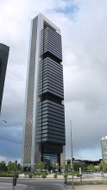 Madrid (España)

Arq. [Halvorson and Partners](http://es.wikipedia.org/w/index.php?title=Halvorson_and_Partners&action=edit&redlink=1) y Norman Foste

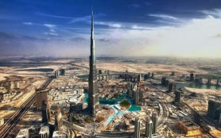 Dubái, Emiratos Arabes

 829,8 metros

Adrian Smith

**BURJ KHALIFA**

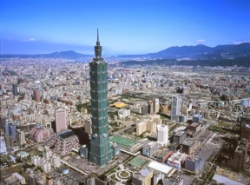 Taipéi, Taiwán

**TAIPEI 101**

449 m

C. Y. Lee

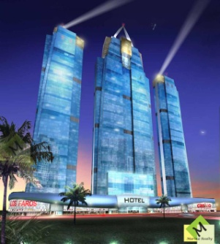

|  |  |  |
| --- | --- | --- |
| FAROS DEL PANAMÁ* | 346 | [Punta Pacífica](http://es.wikipedia.org/wiki/Punta_Pac%C3%ADfica) (PANAMÁ) |

Chapman Taylor

|  |  |  |
| --- | --- | --- |
| [Mercury City Tower](http://es.wikipedia.org/wiki/Mercury_City_Tower) | [Moscú](http://es.wikipedia.org/wiki/Mosc%C3%BA) | 338,8 |

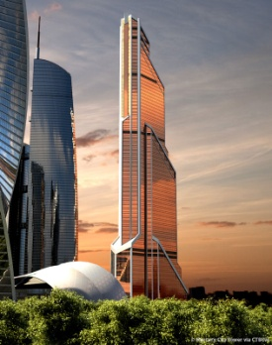[Frank Williams](https://www.google.es/search?sa=X&espv=2&biw=1024&bih=673&q=frank+williams+architect&stick=H4sIAAAAAAAAAGOovnz8BQMDgz0HnxCnfq6-QbphVnm8EheImZRhaW6Rp6WSnWyln1iUnJFZkppcUlqUql9cUlQKZlnBhdO5zY8_ZigqyNkkc3d6qR3XvuMXmAFSd1Y0XAAAAA&ei=TedaVbGgM8SuUdnegbgK&ved=0CNwBEJsTKAEwGQ), [Gennadiy Lvovich Sirota](https://www.google.es/search?sa=X&espv=2&biw=1024&bih=673&q=mercury+city+tower+gennadiy+lvovich+sirota&stick=H4sIAAAAAAAAAGOovnz8BQMDgxMHnxCnfq6-QbphVnm8Eq9-ur6hYZJZYV5BSlWylkp2spV-YlFyRmZJanJJaVGqfnFJUSmYZQUXXvyTfeJpB51Jyg_8T4WudTRbkl2uAQDvOi6UXwAAAA&ei=TedaVbGgM8SuUdnegbgK&ved=0CN0BEJsTKAIwGQ)

|  |  |  |
| --- | --- | --- |
| GRAN TORRE COSTANERA* | 300 | SANTIAGO (CHILE) |

1. 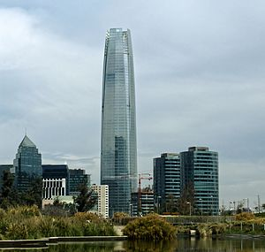[**Arquitecto**](https://www.google.es/search?biw=1024&bih=673&q=gran+torre+santiago+arquitecto&stick=H4sIAAAAAAAAAGOovnz8BQMDgwkHnxCXfq6-gZFZUVZRsZZKdrKVfmJRckZmSWpySWlRqn5xSVEpmGUFF_7363fUxrkXF0zbGyldMfWaQcZsRhMAf1P99VEAAAA&sa=X&ei=6EdcVfPxMsbpUs-bgKAE&ved=0CJ8BEOgTKAAwFw)**:**[César Pelli](https://www.google.es/search?biw=1024&bih=673&q=cesar+pelli&stick=H4sIAAAAAAAAAGOovnz8BQMDgz0HnxCXfq6-gZFZUVZRsRIniG2eV2WZraWSnWyln1iUnJFZkppcUlqUql9cUlQKZlnBhS-quRza6192oixBK2OaLtfOzx6HxQFAfWiGXAAAAA&sa=X&ei=6EdcVfPxMsbpUs-bgKAE&ved=0CKABEJsTKAEwFw)

|  |  |  |
| --- | --- | --- |
| LANDMARK TOWER | 296 | YOKOHAMA (JAPÓN) |

2. [**Arquitecto**](https://www.google.es/search?es_sm=93&q=yokohama+landmark+tower+arquitecto&stick=H4sIAAAAAAAAAGOovnz8BQMDgzEHnxCnfq6-gUlVRUq2lkp2spV-YlFyRmZJanJJaVGqfnFJUSmYZQUXDvmrtORU0ZWVP2ZZL33N_6fKebl7MABOmfxOUAAAAA&sa=X&ei=3UhcVbHkLcn0Us-0gegD&ved=0CL8BEOgTKAAwHQ)**:**[Hugh Stubbins](https://www.google.es/search?es_sm=93&q=hugh+stubbins&stick=H4sIAAAAAAAAAGOovnz8BQMDgx0HnxCnfq6-gUlVRUq2EpiZlpJtUqWlkp1spZ9YlJyRWZKaXFJalKpfXFJUCmZZwYW79rGLnrvWeciGrbH4saGG0436uRoANGXT7lsAAAA&sa=X&ei=3UhcVbHkLcn0Us-0gegD&ved=0CMABEJsTKAEwHQ)

|  |  |  |
| --- | --- | --- |
| LEATOP PLAZA* | 303 | GUANGZHOU (CHINA) |