Instructional Design – 2nd Grade History Unit

Madihah Almotairi

Bowling Green State University

Rationale

History is just as important as other units of social studies. History can be explained in lists of stories that keep students entertained. This subject is marked by the understanding that the past will help people understand the present and anticipate the future. This is useful in terms of cultivation among students’ optimism and national morals when they know more about the history of their country. It is also great to see the importance of characters in history and how they have served their countries. Therefore, in this unit, my lesson plans will focus on how to attract students in the lesson. I will also add some interesting stories that are related to the unit in order to make sure that students are completely engaged.
In this unit, I will use the “5-E Learning Cycle Model” in my lesson plan. This model will help me explain the lesson easily because it has five important components (Chiarelott, 2006, p90). The first component is to engage students in the lesson and I will lead interesting activities in order to get my students’ attention. The second component is exploring the lesson by giving my students enough time to look over the entire lesson and to take in the general idea of the lesson. Then, according to this model, I will put my students into small groups and ask them to give me explanations of what they understand from the lesson and what their views are. After that, I will extend their exploring to make sure they understand the lesson, and they can apply what they learned in the real world. The final component is evaluation; students will assess themselves to measure the level of their understanding of the lesson (Chiarelott, 2006).

The unit will begin with a timeline. First, the unit will be presented by learning how to use a timeline in numbers, week, and years. Then they will learn how to use a timeline to create a series of events in their community. Students will use different examples to create their own timelines. There will be different activities with using various materials to help the students understand this concept. Also, the lesson will present the comparison between the events in the past and events in the present by using a timeline. The second lesson will be learning about historical figures and it will be connected to the first lesson by using timelines for historical people. Also, this lesson will contain development of research skills by doing numerous researching activities. The third lesson of this unit will be about technology and science. This lesson will start with the methods of communication in the past and now. Also, the role of technology nowadays and the type of traveling over time will be discussed in this lesson. The last lesson will be about change over the time. This lesson introduces change over time in our community. It will also describe different examples about how the change happens.
At the end of this unit, students will be able to gain new skills and knowledge that will help them increase their academic achievement. The main objective of this unit is applying contextual teaching and learning theory; therefore, this unit will focus more on how to connect what students learn to real world situations. The examples and activities that we will do in this unit will clarify this theory. Using CTL theory will make students feel the value and the importance of what they have learned because it connects to real life. It helps students explore the meaning of the concept and improve their thinking and problem solving (Johnson, 2002).

Unit outcomes
Sub unit 1: timeline
- Students will identify how to use calendars in order to understand a series of events. (Knowledge)
- Students will explain a series of different events. (Comprehension)
- Student will discuss different examples of timelines in the past until present time. (Knowledge)
- Students will create their own timeline. (Application)
- Student will use butcher paper to create a series of events. (Application)
- Students will use timelines to list days, numbers, and weeks. (Synthesis)
- Student will discuss timelines in historical documents, articles, and pictures. (Knowledge)
- Students will compare events in the past and events in the present by using timelines. (Synthesis)
Sub unit 2: individual impacts history
- Student will explore different sources to search for historical figures. (Synthesis)
- Students will know how to use history books and biographies. (Evaluation)
- Students will identify historical characters, such as Martin Luther King Jr. and Abraham Lincoln. (Knowledge)
- Students will understand the lives of historical people. (Comprehension)
Sub unit 3: science and technology
- Students will discuss the types of communication now and in the past. (Analysis)
- Students will discuss examples of various communication methods. (Analysis)
- Students will contrast traveling in earlier times and now. (Evaluation)
- Students will identify different kinds of traveling methods in the past and now. (Syntheses)
- Students will explain the role of technology in present day. (Application)
Sub unit 4: change over time
- Students will explain change over time by using different materials, such as maps, artifacts, and photographs. (Application)
- Students will describe different perspectives on how change happens over time. (Analysis)
- Students will explain many examples that show the changes in their life. (Evaluation)

Preassessment
At the beginning of the class, the teacher must evaluate the skills, knowledge, and abilities that the students have before starting the lesson. It helps the teacher knows the weaknesses of the students. Then the teacher must strive to find out the best method to help them. Preassessment is a good tool that teachers can use in order to achieve their learning outcomes.
Preassessment is a tool that shows what students have mastered from previous knowledge and skills. The purpose of doing preassessment is to help the teacher to determine if the students can reach the outcomes of the unit or lesson and if they have previously achieved the objective (Chiarelott, 2006).
According to (Oberg, 2009) the importance of preassessment is to give teachers an opportunity to explore their students’ knowledge, skills, and experiences that they already know. Preassessment has an impact on the learning process because it plays an important role as an effective tool in learning.
In this unit, the preassessment tool that I will use is a survey. I would like to know my students’ previous knowledge and skills. Also, I would like to know their interests before we start the unit. Therefore, I will make two surveys, one to examine their knowledge and the second one to explore their interests.

Name: Date:

Student Interest Survey
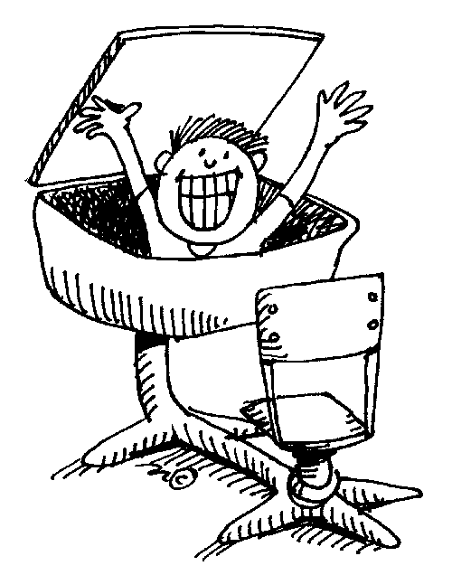
1.The three things that I do best in school are:
1. _________________________
2. _________________________
3. _________________________

2.Some of the things that I would like to work on this year are ___________________________________________________________________________________________________________________________

3. I would like to learn more about_________________
________________________________________________________________________
________________________________________________________________________

4. Outside of school, my favorite activity is________________________
_______________________________________________________________________

5. My hobbies are___________________________________________
_______________________________________________________________________

6. The clubs, organizations or private lessons that I participate in are ____
_______________________________________________________________________
_______________________________________________________________________

7. My favorite sport is _______________________________________

8. The sports that I play in and out of school are____________________
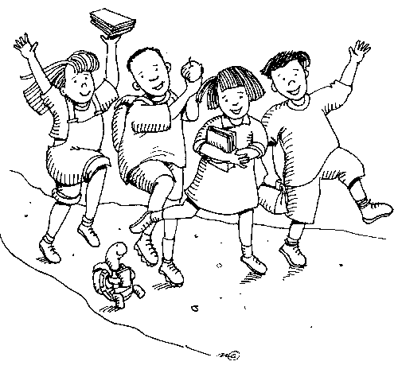
______________________________________________________

9. My three favorite books are:

1. ________________ 2. ____________________ 3. ____________________

Tangient LLC. (2005). Dareto differentiate - Search. Retrieved from
http://daretodifferentiate.wikispaces.com

10. One of my favorite authors is __________
because________________________

11. If I could choose between watching television, playing video games or using the computer, I would pick__________________because_________________________________________________________________________

12. I enjoy these types of reading: (circle those that apply)
Story Books Craft/Games/Puzzles
Fiction Fairy Tales
Non-Fiction Geography
Comics Sports

13. The person that I consider to be a hero is _____________________
because________________________________________________
______________________________________________________

14. I have traveled to _______________________________________
If I could pick a place to travel to, I would choose___________________
________________________________________________________

15. Some of the chores and responsibilities that I have at home are _____
______________________________________________________________________

16. Three of my friends are: __________________________________ ____________________________When I am with my friends we like to ________________________________________________________

17. Something about me that I’d like to share with you is_______________________________________________________ _________________________________________________________

Tangient LLC. (2005). Dareto differentiate - Search. Retrieved from
http://daretodifferentiate.wikispaces.com

Name: Date:
Students’ beliefs about history:
Choose the letter that you think it is right:
A= Agree D=Disagree U=Unsure
- Knowing the history of your country is important. A D U
- I feel that I can use the calendar in different ways. A D U
- I do not care about historical figures. A D U
- I like to search for historical figures. A D U
- I am interested in history and the lives of historical people. A D U
- I do not care how people communicated in the past. A D U
- I like to use technology in my studies. A D U
- I like to see different perspectives of history. A D U
- I like to read history books and articles. A D U
- Historical people can have an impact on people nowadays. A D U
Answer the following questions:
- What do you think the reason is that communities change over time?

- Do you believe that historical people have a role in creating our history?

- How we can connect our history to our life today?

- How do people that influence our community now compare to historical people?

- How can you look for historical resources?

Lesson plan #1
Timeline
The concept to be learned:
What a timeline is and how to create a series of events using a timeline?
Lesson outcomes:
- Students will identify how to use calendars in order to understand the series of events.
- Students will explain a series of different events.
- Student will discuss different examples of timelines in the past until now.
- Students will create their own timeline.
- Student will use butcher paper to create a series of events.
- Students will use timelines to list days, numbers, and weeks.
- Student will discuss timelines in historical documents, articles, and pictures.
- Students will compare events in the past and now by using timelines.
Time requirements: two days.
Materials Needed:
- Calendar
- Butcher paper
- Markers
- Pictures and newspaper
- Timeline worksheets
Procedures:
Day 1: I will engage the students by doing a worksheet activity. This activity will introduce the lesson to the students. Then, I will explain the concept to the students and help them complete the worksheet. (15 minutes)
Day1: Students will be able to explore the meaning of timelines and will begin to identify the series of events. They will start first, with knowing the order of numbers, weeks, and days in the calendar. After that, we will review pictures, newspaper, and historical documents that have examples of timelines. Students will have time to look through these examples. (15 minutes)
Day1: Students will show their understanding by giving me explanations of what they found in the newspaper, pictures, and historical documents. They will share what they found with each other and they will make a comparison and discuss that in the class. (20 minutes)
Day2: I will examine the students’ understanding and I will allow students to create their own timelines. We will do an interesting activity, which is using butcher paper and markers to create timelines about events in their community. After we finish this activity, students will share their timelines with the class. (35 minutes)
Day2: I will provide the students with a blank timeline worksheet and I will give them six American holidays and they must put them in order. After that, I will collect the students’ worksheets to assess their understanding of the timeline. (15 minutes)

Name: Date:
Using timeline, put these events in order by date:
Independence Day - Labor Day- New Year's Day - Memorial Day - Thanksgiving Day.
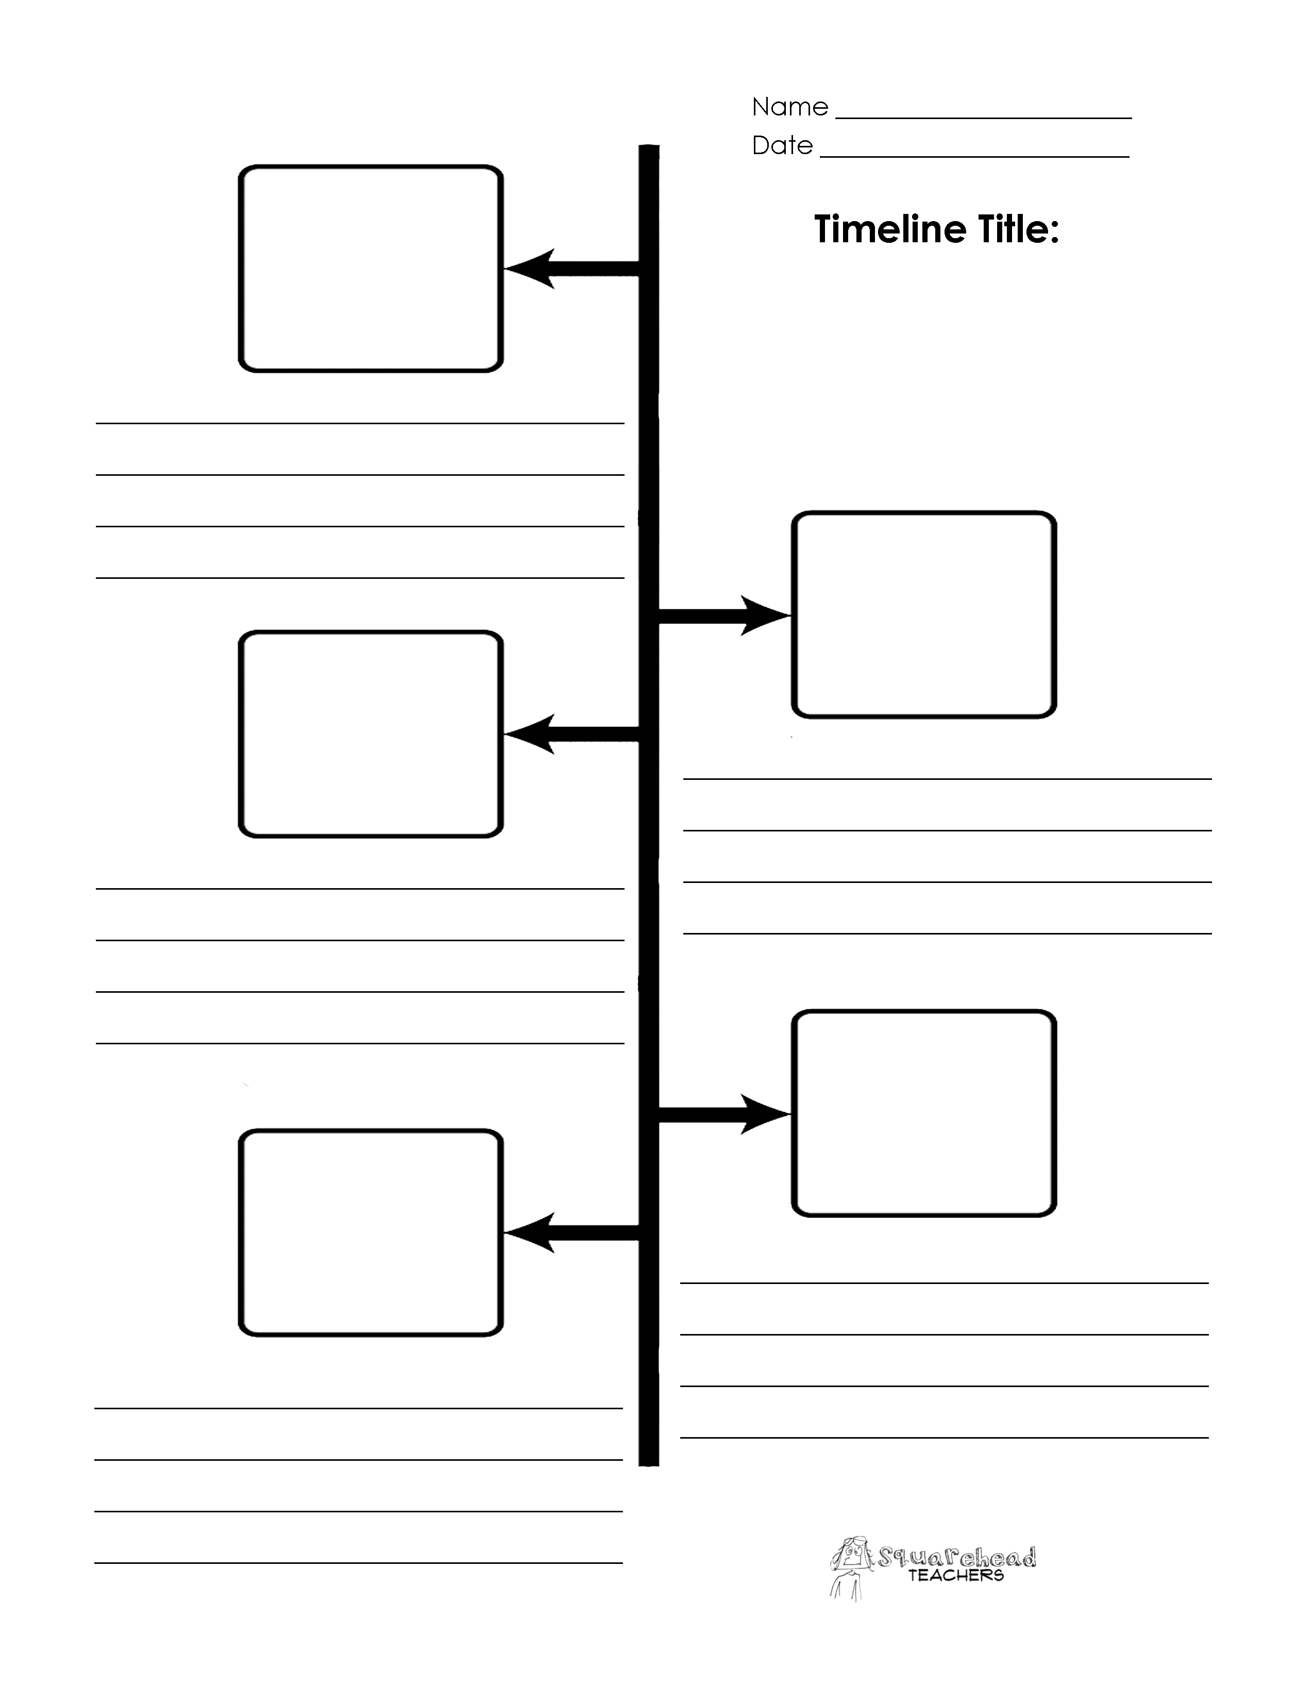
Squareheadteachers. (2013, August 14). Blank Timeline Printables | Squarehead Teachers.
Retrieved from http://squareheadteachers.com/2013/08/14/blank-timeline-printables/

Jerry, & Charles. (2008). K12 Reader. Reader Instruction Resource Retrieved from
www.k12reader.com

Lesson plan #2
Individual impacts history
The concept to be learned:
How historical individuals have influenced history and their accomplishments.
Lesson outcomes:
- Student will explore different sources to search for historical figures.
- Students will know how to use history books and biographies.
- Students will identify historical characters, such as Martin Luther King Jr. and Abraham Lincoln.
- Students will understand the lives of historical people.
Time requirements: two days.
Materials Needed:

- Access to the Internet
- Paper and pens
- Martin Luther King Jr. story
- Abraham Lincoln story
Procedures:
Day1: I will introduce the lesson to the students by showing them a short video about how individuals enrich history and help the community. After that, I will divide them into small groups and ask them to discuss the video. We will share the students’ opinions with the class. Then, I will read the Martin Luther King Jr. story to them as an example of an individual who helped the community. After that, we will discuss the story and I will ask them to answer questions about the story. (25 minutes)
Day1: I will read the second story, which is the Abraham Lincoln story. I will increase their knowledge by telling them how Lincoln has impacted history and his achievements in history. Then, they will answer the questions on the worksheet. After reading this story, students will recognize whom these individuals are and that they can change the community and help their community. (15 minutes)
I will explain to them how to use different methods to improve their researching skills. I will show them how to use history books and biographies on the Internet. Then, I will ask the students to use the Internet to search for historical people such as, Martin Luther King Jr. and Abraham Lincoln. They will have approximately ten minutes to do their research. After they finish, we will discuss what they found as a class. I will ask students to write their ideas about what they found after their research. Then, I will ask them to explain their ideas and opinions about historical people. (15 minutes)
Day2: I will make an activity to measure the students’ understanding. They will use the Internet. Then, I will ask them to list individuals who have impacted history and how they have made a change in the community today. After that, students will have an opportunity to explain their responses. (25 minutes)
Day2: At the end of the lesson, students will have an assessment to evaluate their understanding. The assessment is to write one sentence about how individuals have impacted history. (20 minutes)

Student name: Date:
Education.com. (2006-2015) Education.com. Retrieved from http://www.education.com

Student name: Date:
Education.com. (2006-2015) Education.com. Retrieved from http://www.education.com

Lesson plan #3
Science and Technology
The concept to be learned:
The role of technology and science in history and its uses in the past and present.
Lesson outcomes:
- Students will discuss the types of communication used now and in the past.
- Students will discuss various examples of communication methods.
- Students will contrast traveling in earlier times and the present.
- Students will identify different kinds of traveling methods in the past and now.
- Students will explain the role of technology in present time.
Time requirements: two days.
Materials Needed:
- Access to the internet
- Pictures of different kinds of transportation
- Markers
- Paper
Procedures:
Day 1: I will introduce the lesson by asking the students to brainstorm the different types of communication in the past and now that they already know. They will write their thoughts on separate pieces of paper for approximately 10-15 minutes. After that, I will put them into small groups and I will ask them to discuss what they wrote. Then, I will show them pictures that illustrate the differences between transportation in the past and now. I will discuss these differences with the class. (25 minutes)
Day 1: For the second activity, I will ask the students to gather more information about communication and traveling methods in the past and present. They will access the Internet and write what they find on the board. Then, they will make a comparison of how the communication has changed from the past and now. (25 minutes)
Day 2: I will ask students to take one example that we discussed and write on a piece of paper one kind of traveling or communication and what it was replaced with in the present. For example, in the past we listened to the radio and now we use media players. (20 minutes)
Day 2: I will bring books, animal toys, a radio, and cell phones to class and I will put the students into small groups. Then I will give each group one thing and they will tell me each of these samples what it is replaced by in the present day. Then we will discuss how technology and science impact our daily lives. (20 minutes)
Day 2: At the end of the class, I will assess students by providing them activities for homework and they will bring it back the next day. The last (10 minutes), I will give the students an opportunity to ask questions about the lesson or homework.

Name: Date:
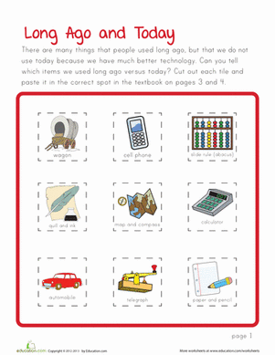
Education.com. (2006-2015) Education.com. Retrieved from http://www.education.com

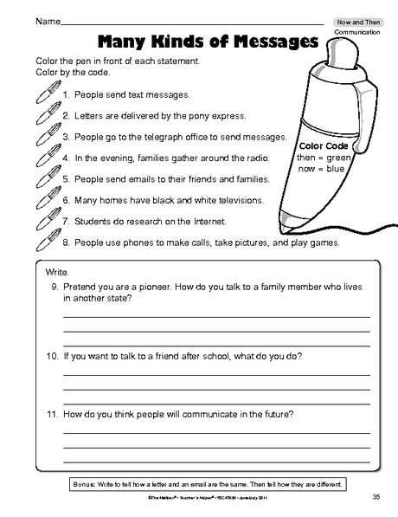

Marge, & Michel. (2015). The Mailbox. The Education Center, LLC Retrieved from
http://www.theeducationcenter.com
Lesson plan #4
Change over time
The concept to be learned:
Explain the change over time in the community by using maps, artifacts, and photographs.
Lesson outcomes:
- Students will explain the change over time by using different materials, such as maps, artifacts, and photographs.
- Students will describe different perspectives on how change happen over time.
- Students will explain many examples that show the change in their lives.
Time requirements: two days.
Materials Needed:
- Maps
- Artifacts
- Photographs
- Papers
- Markers
- Access to the Internet
Procedures:
Day 1: I will engage the students in the lesson by asking them if they notice any change in their community from a few months ago. What are the new buildings and schools? Then, I will give them a worksheet that shows home life in the past and now. After that, we will discuss their answers as a class. (15 minutes)
Day 1: I will ask them to access the Internet and explore different websites to look for different pictures that describe the change in countries, culture, and communities. Then, we will discuss what they found and I will explain to them how communities have changed over time and the elements that have caused that change. (15 minutes)
Day1: I will provide students with maps, artifacts, and photographs and I will ask them to explore these samples and make a comparison using the sample between the past and present. Also, they will explore how these samples are changing over time. I will give them about 15 minutes for this activity. After they finish their exploring, I will ask them to explain how these samples change over time. I will divide them into groups and each group will talk about one sample and explain what the sample is and how it changed from the past until now. (20 minutes)
Day2: I will expand students’ knowledge about this lesson by asking them to write about the changes that happen in their lives. They will complete a worksheet that I will provide and they will work on it individually. Then, we will discuss their answers as a class. (20 minutes)
Day 2: To evaluate students, I will ask them to create their community or neighborhood map and draw pictures to show how their communities or neighborhoods have changed over time. This activity will assess students’ understanding of the lesson (20 minutes). The last 10 minutes I have left for students if they have any questions.

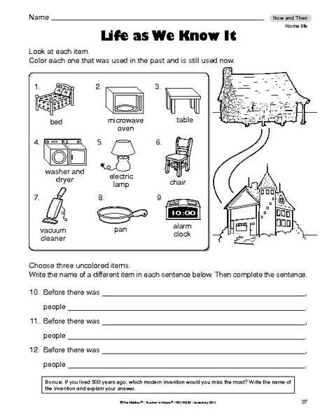
Marge, & Michel. (2015). The Mailbox. The Education Center, LLC Retrieved from
http://www.theeducationcenter.com

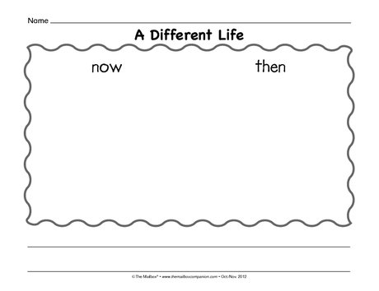

Marge, & Michel. (2015). The Mailbox. The Education Center, LLC Retrieved from
http://www.theeducationcenter.com

Postassessment
Name: Date:
Students’ beliefs about history:
Choose the letter that you think is correct:
A=Agree D=Disagree U=Unsure
- Knowing the history of your country is important. A D U
- I feel that I can use the calendar in different ways. A D U
- I do not care about historical figures. A D U
- I like to search for historical figures. A D U
- I am interested in history and the lives of historical people. A D U
- I do not care how people communicated in the past. A D U
- I like to use technology in my studies. A D U
- I like to see different perspectives of history. A D U
- I like to read history books and articles. A D U
- Historical people can have an impact on people nowadays. A D U
Answer the following questions:
- What do you think the reason is that communities change over time?

- Do you believe that historical people have a role in creating our history?

- How we can connect our history to our life today?
- How do people that influence our community now compare to historical people?

- How can you look for historical resources?

- What is a timeline? When do we use it?

- Create a timeline that shows the popular events in your community.

- Name 3 kinds of technology in the past and what they have been replaced with now.

- What are the ways that people traveled in the past?

- Give one example of people who had an impact on history?

- Describe the change that has happened in your neighborhood from last year until now?

References
Chiarelott, L. (2006). Curriculum in Context: Designing: Curriculum and Instruction for
Teaching and Learning in Context. Belmont, CA: Thomson Wadsworth.
Education.com. (2006-2015) Education.com. Retrieved from http://www.education.com

Jerry, & Charles. (2008). K12 Reader. Reader Instruction Resource Retrieved from
www.k12reader.com

Johnson, E. B. (2002). Contextual teaching and learning: What it is and why it's here to
stay. Thousand Oaks, CA: Corwin Press.
Marge, & Michel. (2015).The Mailbox. The Education Center, LLC Retrieved from

http://www.theeducationcenter.com

Oberg, C. (2009). Guiding classroom instruction through performance
assessment. Journal of Case Studies in Accreditation and
Assessment, 1, 1-11.
Ohio Department of Education. (2013). Model Curriculum: PK-12 Social
Studies.Columbus,Oh Retrieved from
http://education.ohio.gov/getattachment/Topics/Academic-Content
Standards/Social-Studies/Grade-2-Social-Studies-Model
Curriculum_April2014.pdf.aspx
Squareheadteachers. (2013, August 14). Blank Timeline Printables | Squarehead
Teachers. Retrieved from http://squareheadteachers.com/2013/08/14/blank-
timeline-printables/
Tangient LLC. (2005). Dareto differentiate - Search. Retrieved from
http://daretodifferentiate.wikispaces.com

