Instructional Design
3th-Grade Computer
Muradi Alqurashi
EDTL 7100
Spring 2015

Rationale
Every child has his or her own unique development process and pace, others are quick in grasping new ideas while others tend to take time to integrate and learn new concepts. In the same way some are vigorous and aggressive to learn whereas as there are those who tend not to show interest in making discovery of their environments. This fact shades lighter on the idea that children do take a general sequence of predictable growth milestone.
It is therefore relevant for any instructor dealing with children, especially third grade children to be able to understand each of her or his pupils in class and ensure that the approach being used is specific for every child. This will guarantee uniformity in learning even if there is diversity in the character traits of the children. For instance, third grade children are characterized by high energy and they would like to express this through their rough plays and games. They also express high difference in skills and capabilities, this plays a role on how well they are learning and how they can cope with speed of integrating new ideas presented to them. Those who are aggressive prove to be stubborn and unruly, they would like to make discovery of everything new in their environment. They also tend to question the manner in which things function, hence this kind of interest can make them destructive to gadgets.
With all these traits in a third grade child, there are problems that are associated with them and more so in a computer class. This then calls for adequate instructional design to ensure that teaching process takes place smoothly and aims of the lesson are met without being interrupted by these traits. An application of this design is targeted towards solving the problem of destructive inquisitiveness of the children and clumsiness for those who seems to be slow in learning process.
The major problem that third grade students have is how to use computers. They do not know how to use computers; this impacts their ability to learn speedily and effectively. Studies are really changing, teachers use computers to teach and give notes, reference materials as well as illustrations in computers. Essentially, computers are changing the way teaching and learning is done. Fascinatingly, change is not only experienced in learning institutions, but also in almost every aspect of life. This makes learning computer necessary for grade three students. Therefore, it is essential for grade three students to know and understand how the computers operate. Some students in third grade may have experience and understanding of computers; this will provide a platform for them to enhance their knowledge and understanding of computers. As such, this report is based on how to teach computer to third grade students. The primary objective is to teach students, this will make them know how to operate and eventually use computers to solve more complex problems.
Third grade teachers teach their students the names of various parts of a computer. They also teach the students how to use the mouse to maneuver items on the computer screen. At later stages of the third grade, students learn how to use word processing software, paint and draw software as well as how to use the presentation software like the PowerPoint. Teachers teach third graders how to use this software to complete a range of activities such as social studies, language art, science, art and math. These activities form the first steps that teachers teach in third grade, they teach students to use computer to solve problems. Essentially, third grade students can use the knowledge of the computer to solve problems such as mathematics. Teaching computer at such age enables the third graders to develop knowledge as well as interest in computer technology (Reimer & Moyer, 2005).

Teaching computer has many aspects and stages. For third graders, the emphasis is on teaching technology skills through teaching the students how to write, type, create presentations, research, animating, computer art and photo editing. The primary emphasis of teaching a computer to third grade students is on expanding their technology skill set. Teachers can expand their skills set by using a variety of applications as well as building in depth computer skills in researching and presentation of their work. Importantly, it is essential for teachers to time and use various programs so that they are flexible. This will make third graders to understand the programs. It is also essential to mix a number of activities in order to suit the different needs of the students as well as the changing schedules (Kuhlemeier & Hemker, 2007).
When teaching computer, the teacher should follow the guidelines set out by the national technology standards for students. This is important, as it will ensure that the students learn according to their level understanding ability. However, the teachers are not restricted to a particular plan of teaching computer to the students. Teaching computer varies from one classroom to another, depending on various factors such as the number of computer workstations in a classroom. The teachers are supposed to come up with lesson plan. The lesson plans should be effective. This is of particular importance because students have different abilities to understand and learn. As such, the computer lesson plans should be accommodating of all students. The teacher should also be able to maximize the student’s potential (Ottenbreit-Leftwich et al., 2010).
It is important to teach third grade students databases and spreadsheets. They may use spreadsheet programs such as AppleWorks and excel to organize data as well as make graphs. As their teacher, it is good to introduce them to making and using database software like Microsoft access and FileMaker Pro. Such database software would help the students to organize information. To ease learning, it is important for the teacher to use already created software; the teacher would only need to feed it information. The teacher can encourage the students to create to contribute class information and build database such the class library of books, ingredients of their favorite foods and such information. Creating such database would help them to apply the computer knowledge into practice; this will be registered in their mind and hence will not forget (Judge, Puckett & Bell, 2006).
The students develop an interest in solving problems using computers. They also respect each other’s work, as they understand the effort and time spent on each project. They develop an interest in technology and spend a considerable amount of time on the programs looking at how they can solve problems. The teacher should encourage students to come up with various databases or create more problems and give the students to solve using the computer. In this way, the teacher will involve the third grader students in compiling, analyzing, organizing as well as synthesizing information in supporting problem solving (Franklin, 2005).
The teacher may wonder if his or her students use the computers to enhance learning taking place in the regular classroom. The teacher may also wonder whether the students use the materials from the classroom to assist them in computer projects. The teacher should not be too much bothered about this because they are doing both of them. The students would spend more time with computers, they will be excited about using computers to work and look for ways of solving problems. Basically, grade three students need to know how to operate computers; it is not only beneficial in their academic success but also on how to interact well in the community (social understanding). The computer lessons have not only taken care of the academic success of the students but also their behaviors. This will help to maximize their potential as well develop a computer interest in them.
Before starting to teach the students the practical side of computer, it is important to teach the theoretical part. The theoretical part is important as it introduces computer, software and computer components. The students will learn the names of the various computer components as well as their function or usage. They will write notes and they will be used as reference when learning the practical use of computer. Teaching the theoretical part first is preferred to teach both theoretical and practical concurrently. This is because the students get enough time to comprehend and contemplate information. They also get to sharpen their skills through improved understanding of the written notes (DiBello, 2005).
Conversely, it is significant for a teacher to ensure that his or her students use computers quite often. Regular use of computers will improve their understanding and knowledge of the computer programs and software. In addition, regular use of computers will increase the students thinking capacity and skills to facilitate their academic learning and also promote creativity. This will ensure that they get maximum benefits from computers; the lesson plan is paramount as well (DiBello, 2005).
In this case, the 5-E instruction model features as the most appropriate to help solve problem of ineptness in some student and even counter snooping in the third grade children. Reason why this model is relevant is that, it has been identified as the most preferred reference point for not only school leader but teachers also in their teaching duties. The model provides an adequate opportunity for the instructor to structure an in-depth understanding of what high quality of teaching entails.
This argument is so because for an instructor to provide quality teaching, he or she needs to be aware first what quality teaching consists of. This can only be established by identifying the objectives of teaching and then understanding one`s students. In this way, one can devise a wide range of approaches to teach and meet the aims of learning, as it is desired.
The five E model of instruction is compost of five basic stages that has to be followed in the right chronology to meet the aims of teaching. The first stage being; Engagement stage, this the instructor can achieve by establishing a positive relationship between students and him as well as among themselves. He or she should structure shared expectations for both parties in the learning process. It means every student will be aware of what he or she is expected during the learning process and the role that the instructor should play. This will also ensure that, code of conduct is set and chances of misunderstanding and misconduct are minimized as low as possible.

Unit Outcomes

Introduction to lessons

- Students will identify the introduction for the lessons like how to treat computer, how to use a computer, hardware components, and every terminology of computer technology, and they will emphasis on the computer components such as keyboard, monitor, printer, mouse, speakers, file, menu, applications, quit, save, folders.
- Students will identify the software and how to work with it.
- Students will identify the basic mechanical knowledge and explain their importance in technology.
- Students will identify the strategies operating Computer and describe the objective of these strategies.
- Students will identify that what can be done by computer and analyze the importance of computer in recent years of life.
Skills development
- Students will describe how to open a Microsoft Word.
- Students will describe how to close a window on their desktop.
- Students will write documents using Microsoft Word program.
- Students will identify how do they minimize or maximize a program in Windows.
- Students will explain databases and spreadsheets such database software would help the students to organize information.
- Students will identify that using e-mail address.
- Students will explain how attached file to an e-mail message.
- Students will write some examples of an e-mail address.
- Students will search information by using the Web and give the students the foundation to treat with it.
- Students will experiment with the draw program.
- Students will draw some shapes and pictures using draw program.
- Students will start to write faster and will identify how to a become computer expert.
Group work
- Students will make group discussions about the importance of computer in recent years of life.

- Students will write stories with the group using Microsoft Word program.
- Students will fall in the blank activity that each computer components with their objectives.
Practice activities

- Students will practice to send e-mail and reply to other e-mail.
- Students will practice to attach file in an e-mail message.
- Students will draw some pictures using drawing program.
- Students will type some sentences in Microsoft Word program.
To achieve the above targets, it is essential for a teacher to ensure that she or he have educational software. Such software would help to reinforce the learning skills of the students. The educational software will also improve the student’s mathematics skills. In addition to the education software, the teacher should provide such items as dictionaries, multimedia encyclopedias, and interactive books on a computer, Internet access and large screen display that are connected to the computer. These items would help the students to get a deeper understanding of the computer and to be able to put into practice what they learn. Essentially, they will enhance learning (Nastasi & Clements, 1992).

Pre-Assessment
http://www.proprofs.com/quiz-school/story.php?title=basic-computer-skills-assessment

Name: ___________
Date: ___________

Chose the correct answer?

1.” How do you open a program such as a Microsoft Word when there are no icons on the desktop?
A.
Right click to reveal all icons.
B.
Restart the computer.
C.
It is not possible to open program if no icons are on the desktop.
D.
Click the start button and select program from the menu.

2. How do you minimize or maximize a program in Windows?
A.
Right click on the mouse.
B.
Go to "File" and select minimize or maximize.
C.
Top the right corner, dash or square.
D.
This function cannot be done.

3. How do you close a window on your desktop?
A.
Go to "File" and select "Close".
B.
Press the "Ctrl" key on the keyboard.
C.
Use the mouse to press the button with the "X" in it at the top right corner of the screen.
D.
Use the mouse to press the button with the _ in it at the top right corner of the screen.

4. A word processing file can be attached to an e-mail message?
A.
Yes
B.
No
C.
Depends on what type of file.
D.
Only to select email addresses.

5. What does the "Reply to All" e-mail function do?
A.
It will generate a reply message to all of the recipients of the message.
B.
It will send a reply message to every entry in your address book.
C.
It will generate a reply message only to the sender of the message.
D.
This function is not possible.

6. Which of the following is an example of an e-mail address?
A.
Www.google.com
B.
Jeandoe.gmail.com
C.
Bob Smith@yahoo.com” (Jenniferjones, 2015)

Name: ________
Date: _________

- Identify each of the hardware components and parts of the computer and tell the importance of each. At least tell two functions of each component and what role they play?

- How will you Access, Microsoft word from the computer screen to open the application and then making a file and saving it with your name in your preferred location and then opening the file again?

- How will you go opening Internet Explorer from the desktop and access the Bookmarks saved on the computer and explore the website?

- Which Program of Microsoft Office can be used to draw tables and has the functions of Drawing, Pencil, eraser, brushers and Color Picker?

- Draw a Square. Color it with a yellow color, and write your name using a Pencil in the same file and save your progress on the computer. Also write your name, age, school name and address using the Best program from Microsoft Office and save it in your name.

Lesson Plan 1:
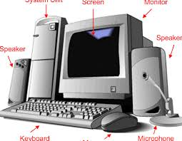
Terminology of computer technology
Unit Objective:
To enable the students to learn and remember the terminology of computer technology, it is important to put emphasis on the computer components such as keyboard, monitor, printer, mouse, speakers, file, menu, applications, quit, save, folders. These computer components and software would help third grade students to properly learn computer with deeper understanding. Actually, knowing these components is the beginning of teaching computer. Knowing the meaning of these components and software would give the students the foundation in computer studies. It would also enable them to use the computers on their own as well.

Time Period Objectives: 45 - 60 minutes
- To learn how to use computer components such as keyboard, monitor, printer, mouse, speakers, file, menu, applications, quit, save, folders
- To exhibit proficiency in the usage of computer technology
- To learn basic computer terminologies
- To know how to use various parts, programs and software for their use
- To instill and encourage critical thinking in students

Materials
Several computers and their components
A worksheet for every student

Procedures
- The teacher expects the students to identify the functions of the various computer components.
- The teacher to show students how to use input devices such as the keyboard, mouse and voice recorders
- The teacher to show students how to use the output devices such as the printer, disk drive, display screen and multimedia projector
- Show students how to save, retrieve files and delete files
- The teacher to describe the purpose of files, directories and drives
- Demonstrate to students how computers use instructions
Objective
The aim of this lesson is students to understand and demonstrate the nature and operation of the computer terminology systems. In addition, the lesson aims to help students to exhibit proficiency in the usage of computer technology. The lesson also aims to help the students to develop basic computer skills.

Evaluation strategy\ Activity
The teacher to use the general-purpose productivity peripherals and tools to support the students productivity, facilitate their learning and immediate deficit in skills. To assess if the students have learned, the teacher will create collaborative and independent multimedia products by using various presentation tools, using various presentation tools will score them scored by classroom created marking rubric.

Key Questions for Lesson
- What are the functions of the various computer components?
- What are the input devices and the output in the computer?

Assessment
Participation in-group discussions about these:
- What are the importance and objective of the hardware components? (10 minutes).
- What are the input devices and the output in the computer? (10 minutes).

Lesson Plan 2:
Microsoft word program
Unit Objective:
The teacher is supposed to introduce the lesson by telling the students that they will be learning about Word program. The teacher then demonstrates how to open Word program. Explain to students how to find it from the menu. The students will then open it by themselves.

Time Period Objectives: 40 - 45 minutes
- Open and sale Word program in a computer
- To be able to type and correct mistakes
- To format the work and save changes
- To make changes on the Word program appropriately
- Open and close saved Word program

Materials
Several computers and their components
White board and markers
A worksheet for every student
Procedures
- Students learn how to open a Microsoft Word.
- Students learn how to close a Microsoft Word.
- Students learn how to open the application and then making a file and saving.
- Students learn how to write documents using different color and font.
- Students learn how to draw tables.
- Students learn how minimize and maximize a program.
Objectives
This lesson aims to teach students the correct procedures for opening, saving and closing files using commands and options.

Description
- Explore different ways of demonstrating ideas through the use of word program such as color, graphics, font, and white space.
- Publish information using various media such as printed copy, and monitor display
- Students to participate in writing on the word program as well as create pictures and save the file.

Key Questions for Lesson
- How to use Microsoft Word program?
- How to write different kind of documents by Microsoft Word program?

Evaluation
The teacher will create an activity for the students to complete. The tetcher will ask the students to write a story and format it accordingly. This will help to evaluate learning ability of the students in respect to learning word program
Activity
The teacher will divide students into small groups. The groups will use a computer and word on an activity provided by the teacher. Each group will have a different activity from the others. The activity will involve writing a story and then formatting the word program. The teacher will then mark the work for every group and grade them accordingly. The other students will applaud the best group. This activity will take 35 minutes

Assessment
- Distribute markers to each student and in the smart bored each student has to match at least one picture with the correct answer. (10 minutes).
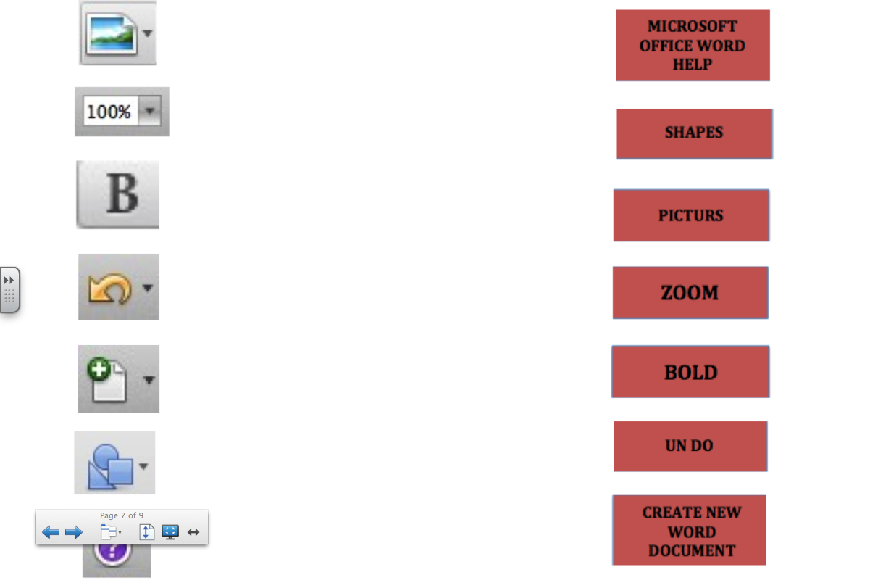

Lesson Plan 3:

How to use the web
Unit Objective:

At this stage, the students have learned computer terminology and the basic Word program. As such, learning how to use the web will be very easy. The teacher should provide several websites for the students. The teacher should then bookmark them and encourage the students to visit them; this will help them to explore what they are taught in the classroom. For instance, the teacher can provide several government websites. The teacher will then use evaluation skills to evaluate their credibility as well as the ability of the students to learn. In addition, the teacher should advise the parents to encourage students to search the Internet in order to learn more about various aspects. This will increase their apprehension.

Time Period Objectives: 40 - 45 minutes
To understand the meaning of web and Internet
To know how to use the Web and Internet
To know the uses of the Web and the Internet
To know how to use the Web to source information and to communicate to friends
To know the purpose of the Web and to use it for the right reasons
To know the limits of the Web and its contents
Materials:
Several computers and their components
A worksheet for every student

Procedures
- Students learn the meaning of web and Internet
- Students learn the various internet tools and their purposes
- Students learn how to open Internet Explorer form the desktop and access the Bookmarks saved.
- Students learn how to use the Internet
- Students use telecommunication tools to interact and collaborate with their peers
- Students to use formats and media to communicate information and their ideas to several audiences.

Objective
The aim of this lesson plan is to help students to effectively search information from the Internet. The lesson aims to teach the students basic aspects of various friendly search engines. The teacher will teach the students how to use keywords to carry out an effective Internet search as well as how to change the keyword search to provide more appropriate results. Students will also learn how to use search engines to find the best sites to get their desired information. After the guided Internet search and other structured search tasks, the students will apply the skills and strategies to research a topic of their choice for a persuasive essay. This will ensure that they understand how to use the web effectively.
Activity
The teacher will divide students into groups. Each group to be assigned an Internet search engine and given a task to search for information, the tasks will be different for each group. The students will then use the web to search information and complete the task given by the teacher. This will be a group work and every student will participate. The teacher will then examine the students’ work and grade them accordingly. This activity will take 30 minutes.
Evaluation strategy

The teacher to use Internet tools such as web tools to create knowledge products to help know if the students have learned. Check how students are using the Internet materials to source information.
The teacher to use online resources such as online discussion and emails to participate in collaborative problem solving activity, the teacher will assess the student’s capacity to generate a solution. Task students to use the Internet to locate, collect and evaluate information from various sources.

Key Questions for Lesson
- What are the meaning of Web and Internet?
- What are the various Internet tools and their purposes?

Assessment
The teacher will look if the students have completed search for information as provided. The teacher will also look for the quality of information from each group and award them marks. This will indicate if the students have understood how to use the web and Internet. (10 minutes).

Unit Posttest

This section explains the importance of all the unit outcomes in the design. The posttest gives the reader the conclusions and the understanding of the design. The protest is usually and short and includes the skills, sub skills and knowledge and learner performance of the students for the design. If something went wrong during the instruction it will be identified where the problem is and will be a guideline to figure out the solution to it.
The Unit Post test will Include Name and Date when the Test was carried out and will have the following Questions on the Test: -
Name: ________
Date: _________

- Identify each of the hardware components and parts of the computer and tell the importance of each. At least tell two functions of each component and what role they play?

- How will you Access, Microsoft word from the computer screen to open the application and then making a file and saving it with your name in your preferred location and then opening the file again.

- How will you be opening Internet Explorer form the desktop and access the Bookmarks, saved on the computer and explore the website?

- Which Program of Microsoft Office can be used to draw tables and has the functions of Drawing, Pencil, Eraser, Brushers and Color Picker?

- Draw a Square. Color it with a yellow color and write your name using a Pencil in the same file and save your progress on the computer. Also write your name, age, school name and address using the Best program from Microsoft Office and save it in your name.

References
Basic Computer Skills Assessment. (n.d.). Retrieved March 29, 2015, from http://www.proprofs.com/quiz-school/story.php?title=basic-computer-skills-assessment

DiBello, L. C. (2005). Issues in Education: Are We Addressing the Digital Divide? Issues, Access, and Real Commitment; Childhood Education, 81(4), 239-241.

Franklin, C. A. (2005). Factors that Influence Elementary Teachers' Use of Computers: Online Submission.

Judge, S., Puckett, K., & Bell, S. M. (2006). Closing the digital divide: Update from the early childhood longitudinal study. The Journal of Educational Research, 100(1), 52-60.

Kim, C., Kim, M. K., Lee, C., Spector, J. M, & DeMeester, K, (2013). Teacher beliefs and technology integration: Teaching and Teacher Education, 29, 76-85.

Kuhlemeier, H., & Hemker, B, (2007). The impact of computer use at home on students’ Internet skills: Computers & Education, 49(2), 460-480.

Nastasi, B. K, & Clements, D. H, (1992). Social-cognitive behaviors and higher-order thinking in educational computer environments: Learning and instruction, 2(3), 215-238.

Ottenbreit-Leftwich, A, T, Glazewski, K, D, Newby, T, J, & Ertmer, P, A, (2010). Teacher value beliefs associated with using technology: Addressing professional and student needs; Computers & Education, 55(3), 1321-1335.

Reimer, K., & Moyer, P, S, (2005). Third-graders learn about fractions using virtual manipulatives: A classroom study; Journal of Computers in Mathematics and Science Teaching, 24(1), 5-25.

Wozney, L., Venkatesh, V, & Abrami, P, (2006). Implementing computer technologies: Teachers' perceptions and practices; Journal of Technology and teacher education, 14(1), 173-207.

