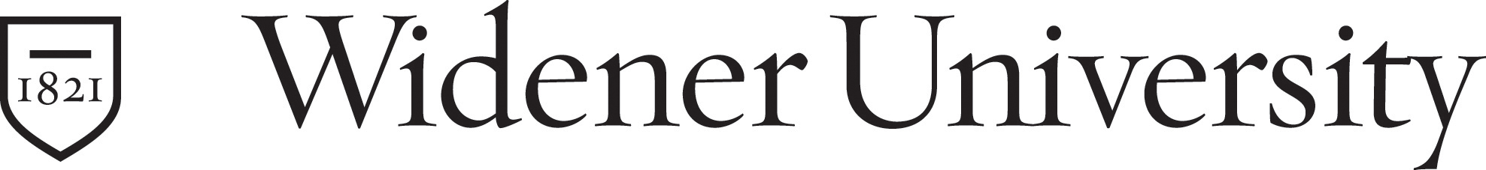

Memorandum

To: Faculty of the College of Arts and Sciences

From: Arts and Sciences Academic Assessment and General Education Committee
Date: 20 June 2007
Re: Proposed Changes to the Mathematics and Quantitative Reasoning Requirement

A. Proposed Changes to the Mathematics and Quantitative Reasoning Requirement

We propose that the general education requirements in mathematics and quantitative reasoning should be changed as follows:

- Satisfactory score on the Mathematics Placement Exam or completion of MATH 101
- Completion of one Mathematics course beyond MATH 101, or completion of PHIL 120
- Completion of two courses designated Quantitative Reasoning (QR) by Science Division Curriculum and Planning. Criteria for QR courses include:
  - The course must contain at least one topic that is discussed in quantitative terms, and the quantitative analysis of the topic(s) must comprise a significant part of the course. In addition to the sciences and mathematics, relevant topics for quantitative reasoning could be found in courses from a broad range of disciplines throughout the University; for example: accounting, criminal justice, economics, engineering, finance, government and politics, marketing, philosophy, and psychology.
  - The course must be structured so that the emphasis is on students doing the reasoning, not just seeing it done. The students’ work should take the form of problem sets, projects, computer programs, field research, or lab reports, for example. There should be opportunities for revision of work.
  - The course must include assessments of the students’ proficiency in quantitative problem solving.
- Attainment of appropriate level of competency on the quantitative reasoning examination, administered by the Math Center in the freshman and junior years.

B. Rationale for Changes

The Committee’s recommendations for change are based on the consideration that college graduates should have a higher level of proficiency in mathematics than high school graduates,
and that the difference should not be a matter of remediation (i.e., completion of a developmental course like MATH 101) but of the acquisition of new skills. In order to fulfill the goals and objectives of the General Education program and the Arts and Sciences Strategic Plan, students’ QR skills need to be strengthened beyond the developmental stage.

These proposed changes would align with both the University General Education Learning Goal 2 (“Students understand and use quantitative methods effectively”) and the A & S General Education Goal 3 (“[Students use] quantitative methods effectively”).

