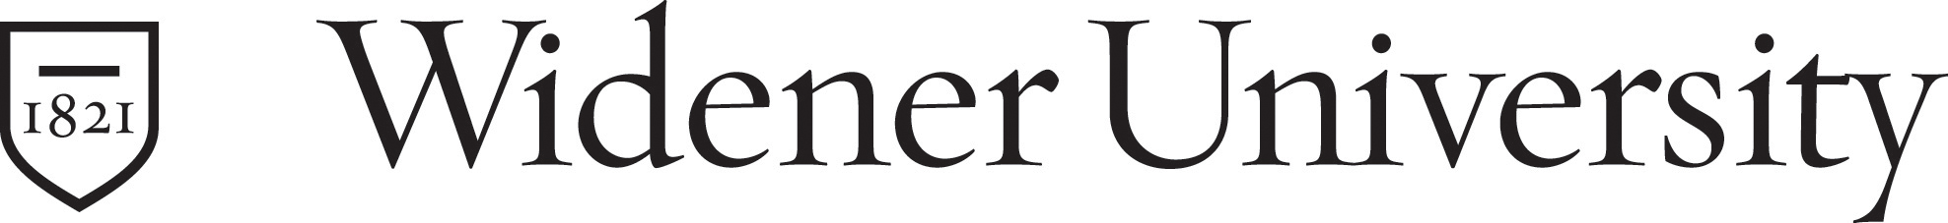
College of Arts and Science

Memorandum

To: Faculty Council Executive Committee
From: Faculty Council Academic Affairs Committee
Date: May 12, 2011
Re: Revision of General Education Goals and Objectives

When the faculty participating in the general education network began work on the assessment of general education in February of 2005 it had been a very long time since general education had been discussed at Widener. The current goals and objectives were a first try at developing language to capture what the faculty believes is important. However, after 4 years and many meetings working on the assessment of the University General Education Goals, it is clear that current general education goals need to be revised.
It is also clear that to make timely progress for the assessment of general education we need to establish University-wide objectives that clarify what students need to be able to do to meet the goals. Lack of common language for objectives is currently a significant barrier to University-wide assessment. For general education assessment to be useful to the University community it needs to foster conversations between different units and identify student strengths and weaknesses.
In order to facilitate this process, Faculty Council Academic Affairs recommends revising the goals as follow:

General Education Purpose Statement
Widener University cultivates critical, creative, and independent thinking to develop undergraduates who demonstrate intellectual integrity, civic engagement and potential for leadership. General education promotes awareness and synthesis of different strategies of knowing, questioning, and understanding. Through the integration of experiences both inside and outside the classroom, students learn to act as responsible citizens and to pursue knowledge beyond the boundaries of the university.
This is commonly referred to as a liberal education, which is defined as:
A philosophy of education that empowers individuals, liberates the mind from ignorance, and cultivates social responsibility. Characterized by challenging encounters with important issues, and more a way of studying than specific content, liberal education can occur at all types of colleges and universities. "General Education" and an expectation of in-depth study in at least one field normally comprise liberal education.

Proposed general education goals and objectives

- A liberally educated graduate communicates effectively.
  - Gives clear presentations before a group.
  - Writes papers that require locating, analyzing, and formally referencing information sources to support conclusions.

- A liberally educated graduate thinks critically.
  - Makes claims and draws conclusions that require the analysis and evaluation of evidence.
  - Synthesizes divergent content, methodologies, and models.
  - Makes and assesses ethical judgments.

- A liberally educated graduate uses quantitative methods effectively.
  - Solves problems using mathematical methods.
  - Interprets, makes inferences, and draws conclusions from data.
  - Determines whether numerical results are reasonable.

- A liberally educated graduate has developed a wide range of intellectual perspectives and methodologies.
  - Evaluates the workings of the natural and physical world using theories and models that can be tested by experiments and observations.
  - Evaluates social science theories and research methods related to questions of human behavior, mental processes, communication, social and cultural structures and institutions.
  - Evaluates philosophical, historical and aesthetic arguments, evidence, and artifacts.

Appendix A - Current University General Education Goals
- Students communicate effectively.
- Students understand and use quantitative methods effectively.
- Students understand the world from multiple perspectives.
- Students cultivate an awareness of themselves and their role within the human community.
- Students cultivate an awareness of their relationship to the natural world.
- Students understand ethical theories and how to apply them personally and professionally.
- Students understand and apply methods of inquiry and interpretation.
- Students think critically.

http://www.aacu-edu.org/advocacy/what_is_liberal_education.cfm

