Eye Exenteration/ Extripation in Cattle

Exenteration is essentially a **Transpalpebral Enucleation + Removal of all adnexa** in the orbit**.**

# Steps in Exenteration

1. **Closure of Eyelids**

Patient’s eyelids are closed to **limit contamination** of surgical site. This is done by using a **simple continuous suture pattern.** The ends are left long to be grasped and apply traction during surgery. Alternatively, closure can be achieved by using towel clamps. This is less secure but faster than sutures. Only moderate traction should be applied to avoid eliciting the **Oculocardiac Reflex** –a decrease in heart rate by 10% following pressure to the globe or traction of the ocular muscles

1. **Transpalpebral Incision**

Starting **1cm** from the **eyelid margin** a **ventrak incision** is made. It is then extendend laterally, **360°.** Note- leave as much normal tissue as possible to enable easy wound closure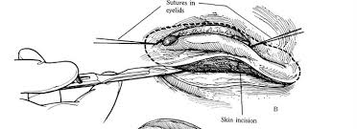

Figure 1Transpalpebral Incision Starting ventrally

1. **Dissection of Subcutaneous Tissue**

Sharp or blunt dissection is carried out, moving **360° & towards the caudal aspect of the orbit.** Dissecting instrument should always be directed toward the orbit- away from the **palpebral conjunctiva.** This is to **avoid penetration of the palpebral conjunctiva** and spread of the contained contaminants**.** During this step, you may use a finger to ensure there is complete dissection of the globe and adnexa from the orbital attachements in all planes

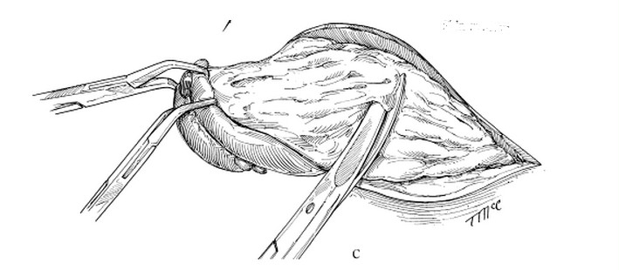

Figure 2- Dissection of Sub-cutaneous tissue

1. **Clamping and Severing Optic Nerve Stalk**

Using a long curved haemostat, locate the Optic stalk and clamp it. Using a Mayo scissors, transect the optic stalk rostral to the clamp.

1. **Content Removal**

Using the long tails of the sutures, remove the globe and adnexa.

1. **Haemostasis**

Some surgeons may ligate the optic artery and other bleeding vessels. Another approach to achieving haemostasis is to pack the orbit with gauze. The combined pressur of the gaze and the accumulating blood causes haemostasis.

1. **Wound Closure**

**A Continuous Interlocking** (or Simple Continuous with inter digitating simple continuous or horizontal mattress) pattern, using **synthetic Non-Absorbable suture material** is used. Sutures are removed in 2-3 weeks.

## Sources

1. Turner’s & McIlwraith’s Techniques in Large Animal Surgery 4th Edition
2. Oculocardiac reflex -http://www.openanesthesia.org/ABA:Oculocardiac_reflex_-_afferent_path