Clinical signs of GI problems

The most common signs of digestive disorders are soft stools or diarrhea, some or all of the following signs may also be observed.

* Vomiting
* Regurgitation
* Flatulence
* Weakness
* Diarrhea/Constipation

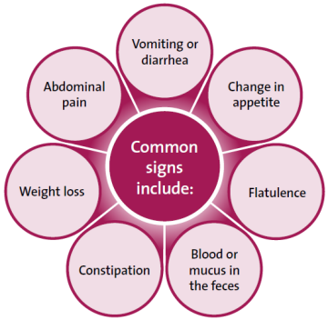

Chronic GI disease can be a debilitating problem and requires testing and a thorough diagnosis.